**NodeJS famous and popular server technology that let us write server code in javascript.**

**It's designed to be able to use JavaScript to write server code.**

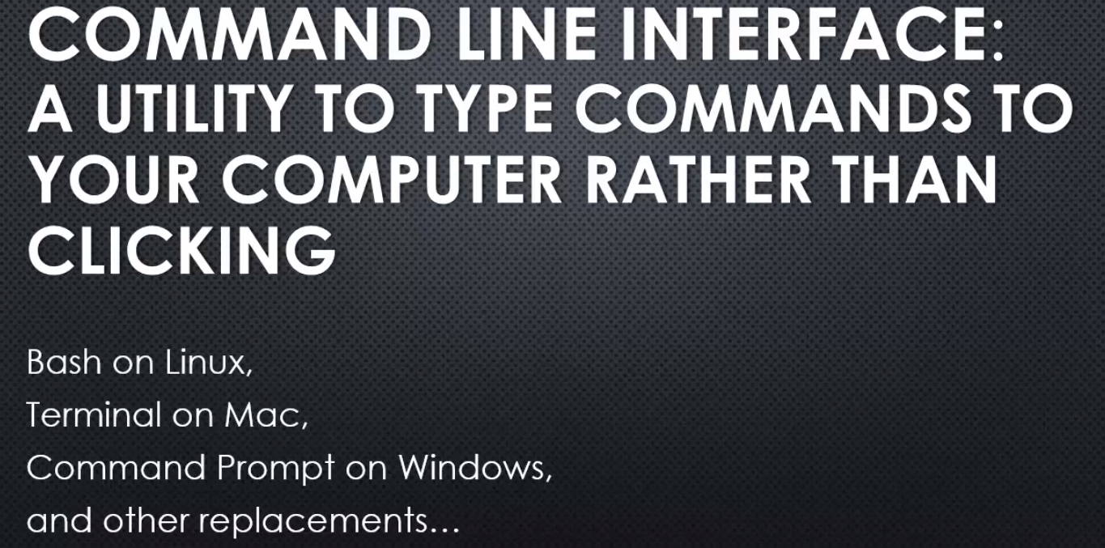

# V8 : the Javascript Engine

The thing at the heart of Node JS is The V8 Javascript engine.

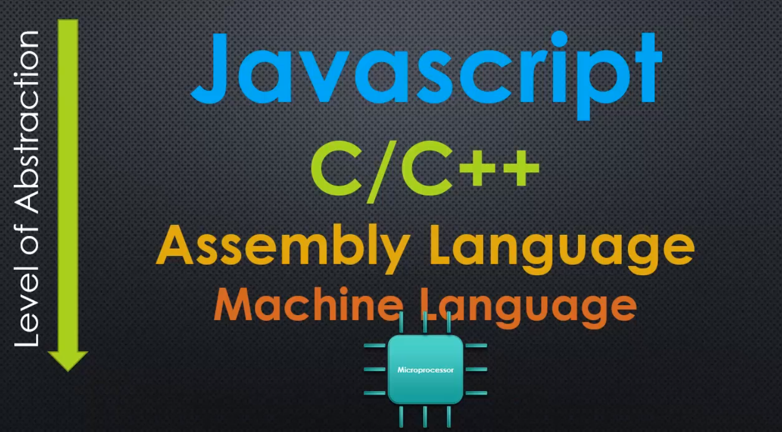

C and C++ still lets you have a degree of control that's lower-level. And so a bit closer to the microprocessor itself. And that's why it's very popular to use, because you have a great degree of control but it's easier to code in than assembly or machine language.

And then you have programming languages, very high-level programming languages like Javascript, which are very far removed from the computer's processor.

**We don't deal directly deal with where memory is and what it's doing.**

**You have an engine between you and the microprocessor that's taking care of all those things for you.**

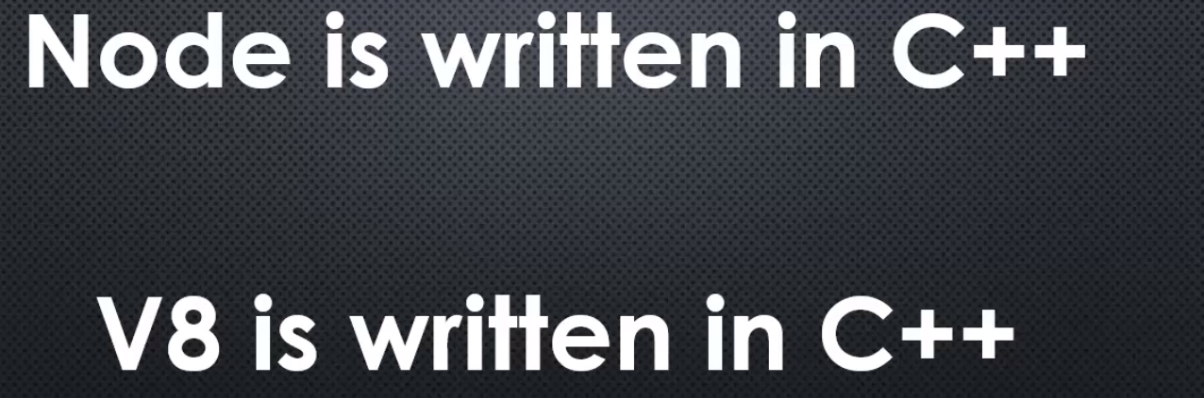

**the reason why Node is a C++ programme, is written in that programming language, is because V8 the Javascript engine is written in C++.**

**V8 the thing that converts Javascript to machine code, is written in C++. And so Node, which adds onto it, is also written in C++**



JavaScript is the actual language that we are writing, and ECMAScript is the standard that says how the language should work, it's a core scripting language standard.

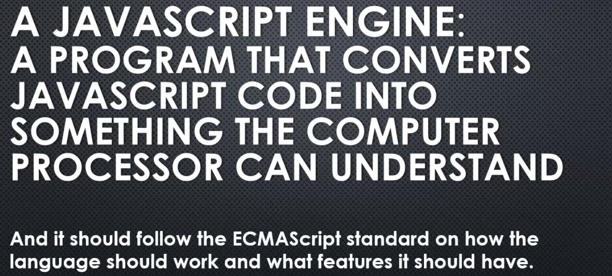

I searched for Chrome V8 because **V8 was primarily written to be used inside the Google Chrome browser, and it certainly is.**

**However, it's also built in a way that let's it be used elsewhere, and in other ways.**

V8 isn't some mysterious black box. It's just a lot of code. Code designed to do exactly what an engine is supposed to do, execute Javascript.

That is to say, convert Javascript code that you write, into something far more based, far lower, and in some ways, more complex.

# **What does Javascript need to have to manage a server?**

What are the features that we need to have accessible in JavaScript in order to do the kinds of things that a web server normally needs to do?

**These are just some of the problems that need to be solved when you're designing a web server, and some of the things that JavaScript simply doesn't have out of the box, and these are the things, among others, that Node.js solves for us.**

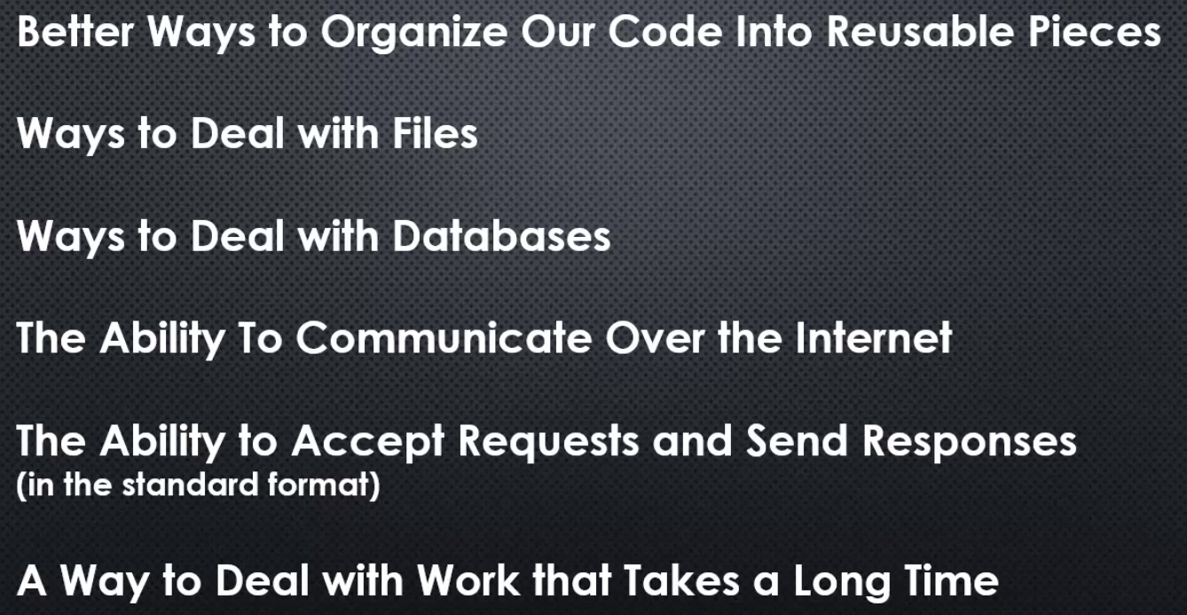

# **The c++ Core**

**The first part of the node core, the core code that makes up node.js is The C++ core, the area of node.js that's about adding the features, about building the base, the foundation of what makes node.js, a web server.**

Let's take a quick look at the node.js source code.

To begin with, we'll go to github.com/nodejs/node.

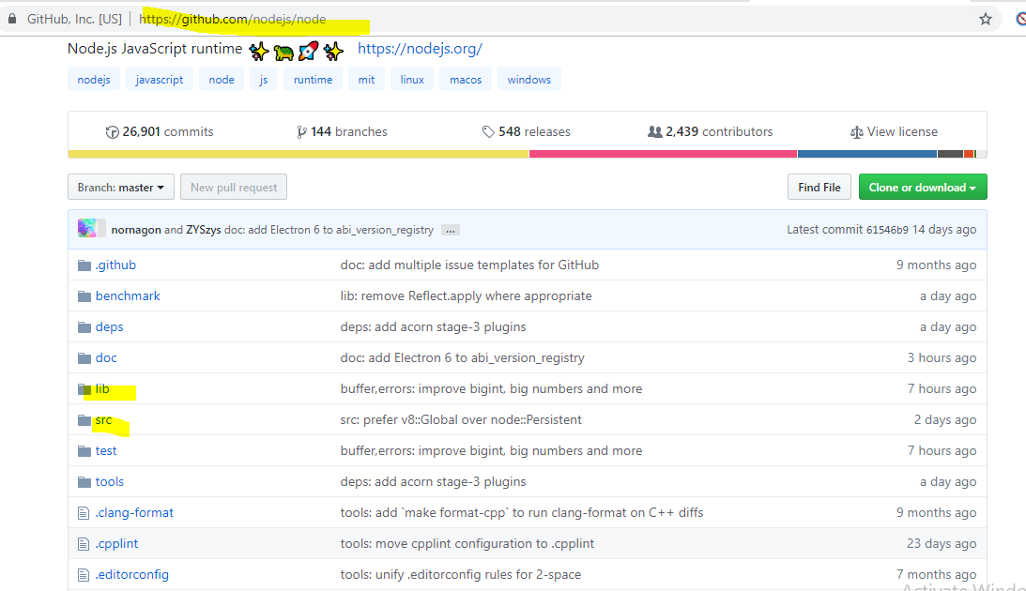

it's full of code, files and folders.

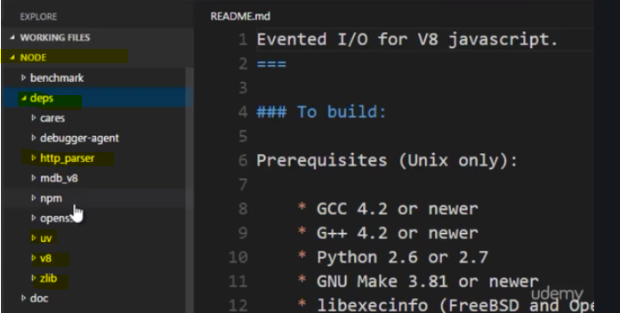

if I go to src/node.h, one of the first lines of code, is what we were to inspect, we're embedding v8. **We're using the v8 engine throughout node.js, to process and execute JavaScript code.**

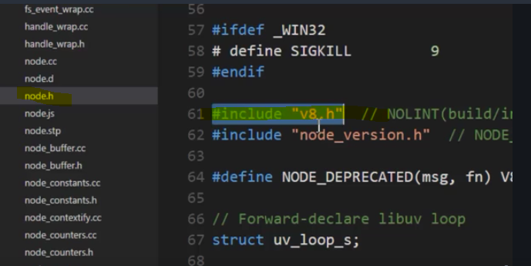

**So, the C++ core, is a core of features of utilities built in C++, made available to JavaScript via the hooks in the v8 engine.**

**The mental model you should have, is not that node.js is JavaScript, but rather that node.js accepts JavaScript and allows to have more features that we write with it than normal.**

# **The Javascript Core**

While the C++ core is one side of Node.js,

there is another side,

the JavaScript side of the core.

**There is plenty of C++ utilities within Node.js, however, there is actually just pure JavaScript that's been written for you to help making using those C++ features easier, as well as also some other common tasks and needs that you commonly have in JavaScript development that's also made available for you within Node.js that comes along for the ride when you install Node.js.**

we're again in the nodeJS source code.

This time we'll focus on the folder called **lib** .

And notice, instead of being full of C++ code, it's full of JavaScript files.

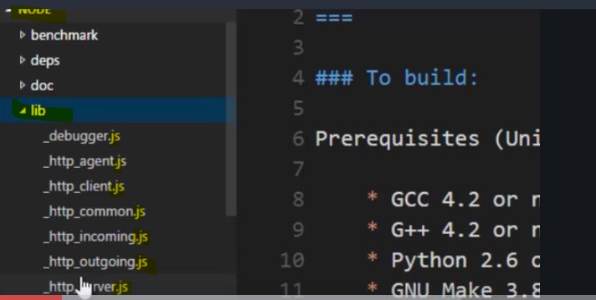

Why?

**Because Node.js also comes with a large amount of JavaScript written for you to perform tasks, and most of these are actually wrappers for the C++ features.**

For example, remember that zlib was for dealing with zip files in C++ core.

Well, if I open this zlib.js, if you were to open up these JavaScript files, you'll find very often this kind of line right here called process.binding, and what process.binding does,

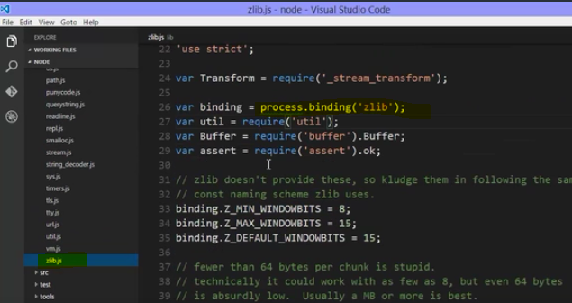

**it's a feature that essentially goes out and grabs the C++ feature, and makes it available inside the JavaScript, so this is essentially going out and getting the zlib C++ object, and then it's being used the rest of the time here in this JavaScript code,**

**so when you use zlib, you're not actually going out and grabbing the C++ library, you're using the JavaScript library that wraps the C++ feature for you. It makes it easier to use and add some features.**

**However, not all of the JavaScript code in here is about wrapping the C++ features.**

**Some things like util.js is just a bunch of functions that are useful, things that you could have written yourself in JavaScript but they've written for you, the kinds of things that you might do often.**

# **Modules, Export and require**

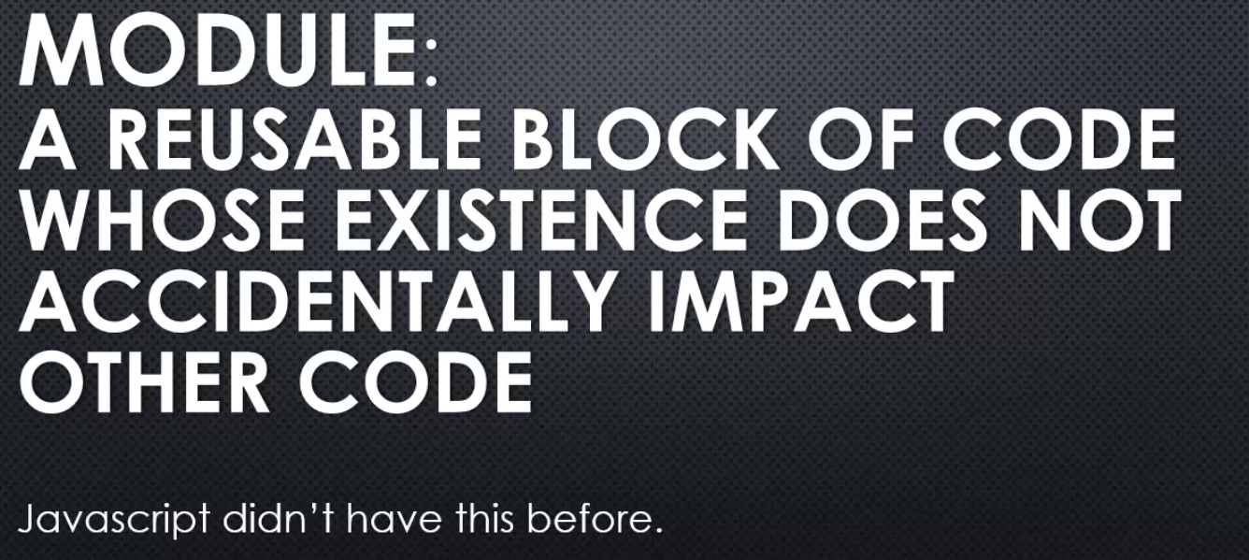

this is a new feature for Javascript in ES 6, the latest version. However, at the time of NodeJS's creation, Javascript didn't have this.

**So NodeJS needed to give us the ability to build code modules, reusable blocks where I could put code in that block of code and it wouldn't impact other code in the rest of my application unintentionally.**

**So NodeJS implements something called CommonJS modules.**



**Example -** 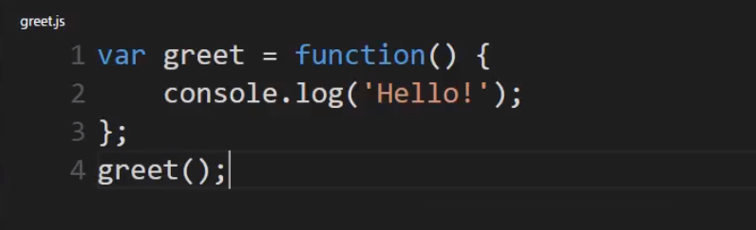

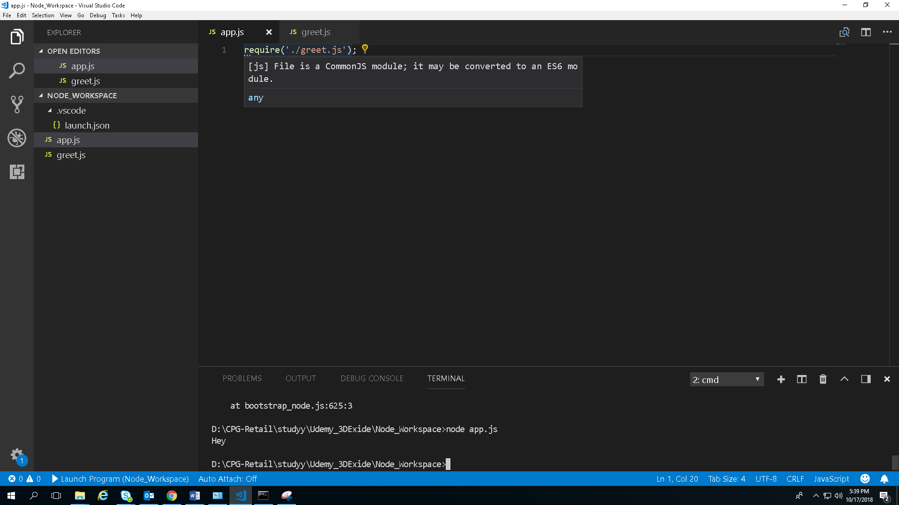

**require is a function that Node makes available inside its javascript core. What you pass to the function, the argument, the parameter is a string, and the string contains the location or the name of the module that you wish to import or that is used.**

**dot slash(./) that I'll put on it means this is in the same location as the javascript file that I'm sitting in right now, at the same folder level.**

Output - 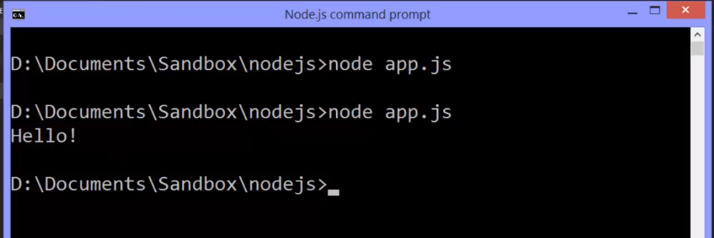

**This means Node grabbed this file and executed the javascript file, pushed it through the V8 engine in its own custom code and it ran, just like that.**

**But now, app.js has loaded this module. Does that mean I can call greet from app.js?**

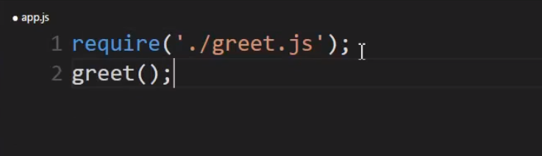

No, greet is not defined.This is by design.

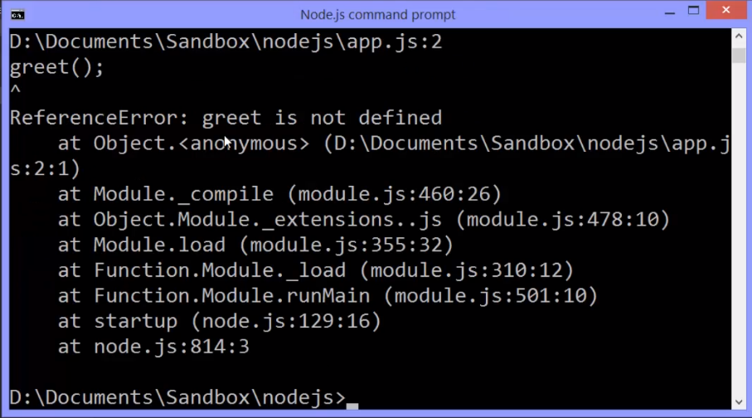

**The code inside greet.js is protected. App.js doesn't simply have access to it unless I want it to. It can't go get its variables, its functions, its objects. We would have to explicitly make that available.**

Node js provides a way to do this.

In my **module I can simply type: module.exports. This is a special variable, a special object, a special place to put things that I want to make available to anything else that uses this module, and only the things I attach to this will be made available.**

**So I choose what becomes available outside.**

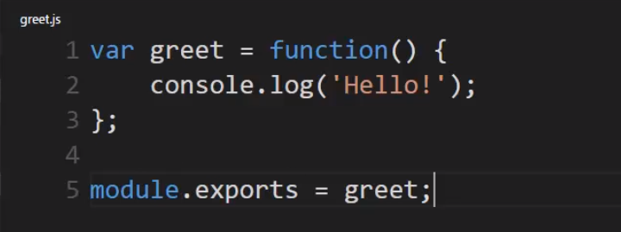

Now, this module is exposing the greet function.

So how can I use this in my app.js file?

Well, I can actually set a variable equal to the results of the function.

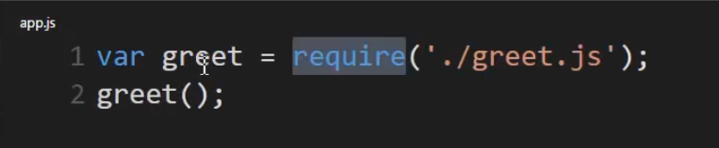

**So Node js says: ah, you want the greet.js file, it runs it and then gives me back whatever I've attached to this special phrase: module.exports.**

**What's also kind of neat is I can actually remove this dot js extension. Node js's require function is smart enough to know that if I'm asking for a module it most likely is a javascript file, because this is Node js we're talking about. So I could run this and it still works. It knew that when I said greet, I actually meant greet.js.**

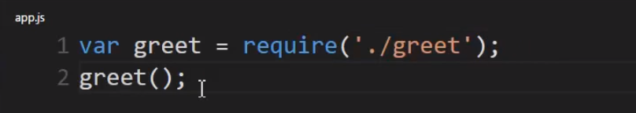

So you might be asking yourself:

well **where did require and module, module.exports, where did those come from?**

**Well they're defined inside a javascript core.**

When I wrote my greet.js file I have some code. Node runs this, but rather than simply running this code through the V8 engine, it wraps it inside a function expression using those parentheses to create that function on the fly. And, this function expects five parameters.

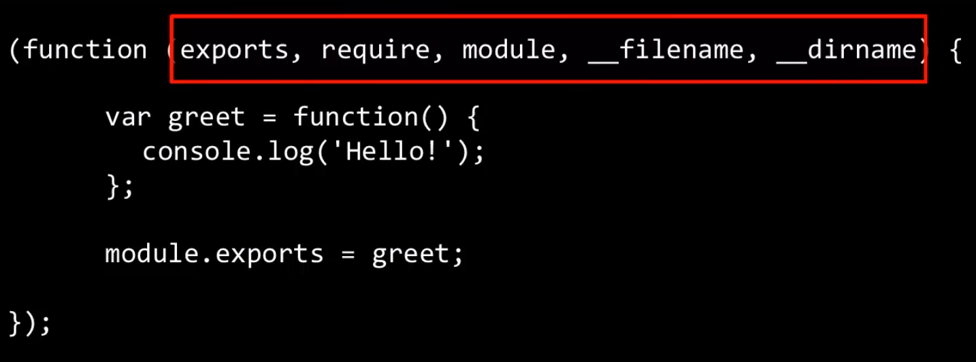

**Module is available to my code when I'm writing in Node, because my code isn't what's actually the only thing that's run. My code is wrapped in a function, and that module is a parameter to that function, and Node passes it in.**



**And, the last thing to note is what actually is returned then from require is module.exports.**

**My code is actually wrapped in a function, which means the variables that I create, the functions I create inside there are protected inside that function. They're not available outside.**

**But, because of passing by reference, because the module object is passed by reference I can then use that as my window to outside my function. So, I can change the module, and because it's pointing at a memory space that's available outside my function, I can change it, and that change becomes available outside this secretly wrapped function.**

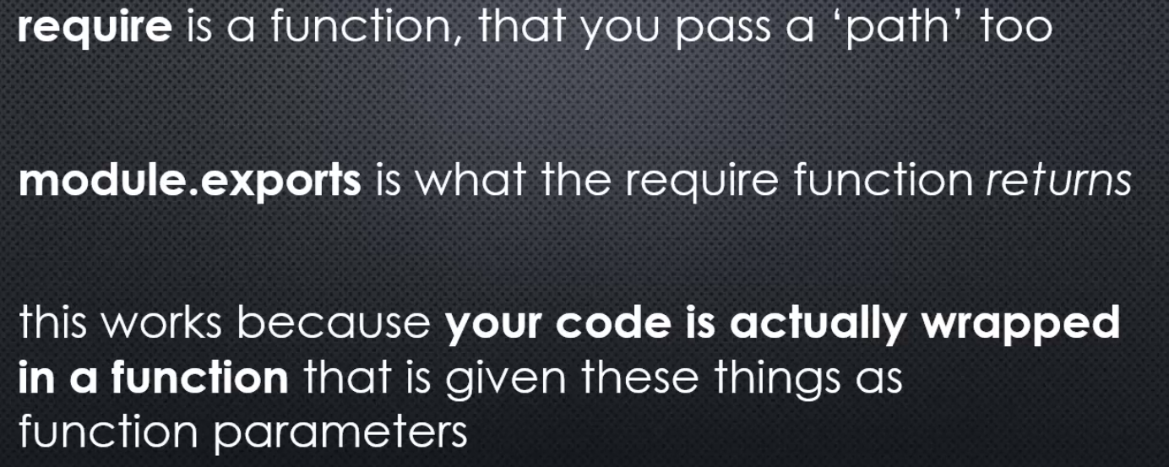

**More on require**

**Is require only able to grab a single JavaScript file?**

**What if the module I want to build is quite large and needs to split into several files?**

**Is there any other kinds of files I can require other than .js files?**

Lets Answer above questions

**I can require greet, and since there is no greet.js file, the require function will instead look for a greet folder. Then it will look inside that greet folder for a file simply called index.js.**

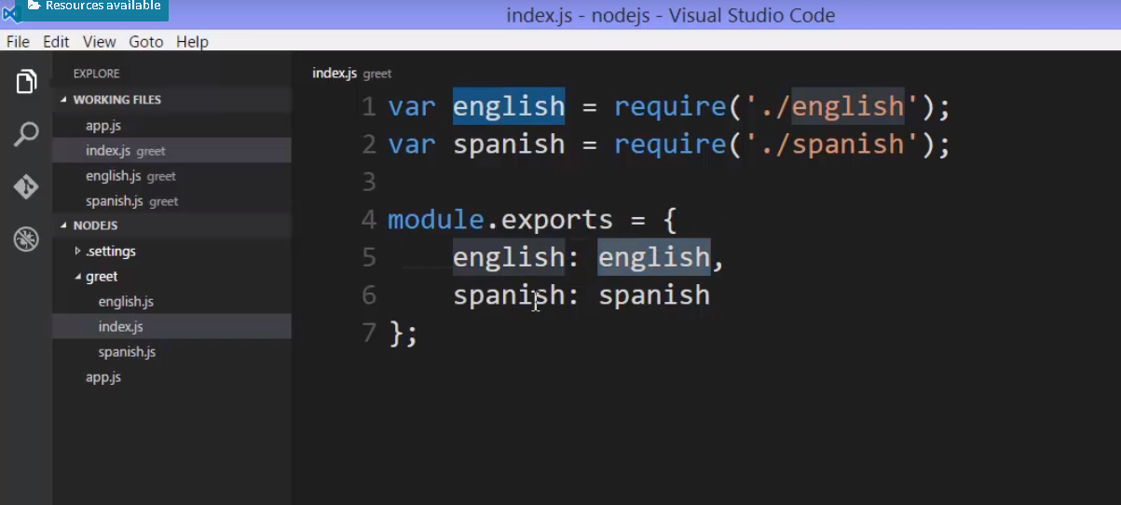

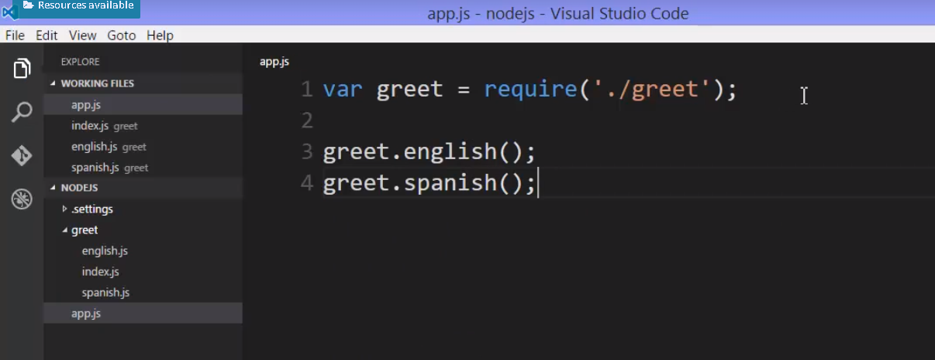

**require function also has ability with a node to process a .json file.** 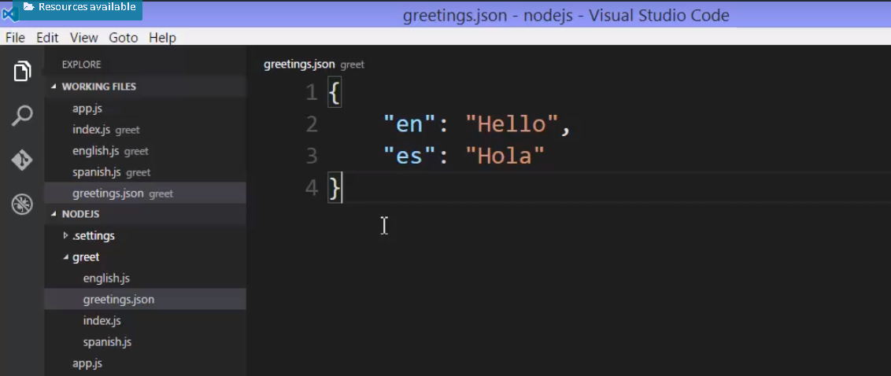

**And JavaScript can read this and convert it into an object much like it does with object literal syntax. The require function will actually do that for me.**

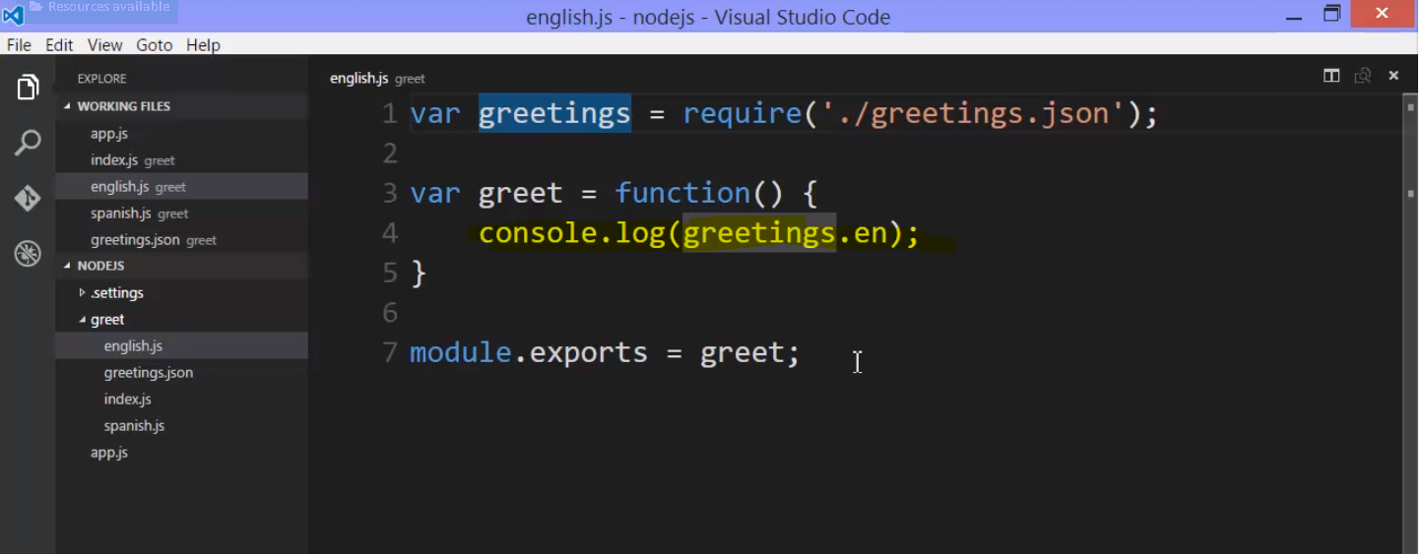

**module patterns**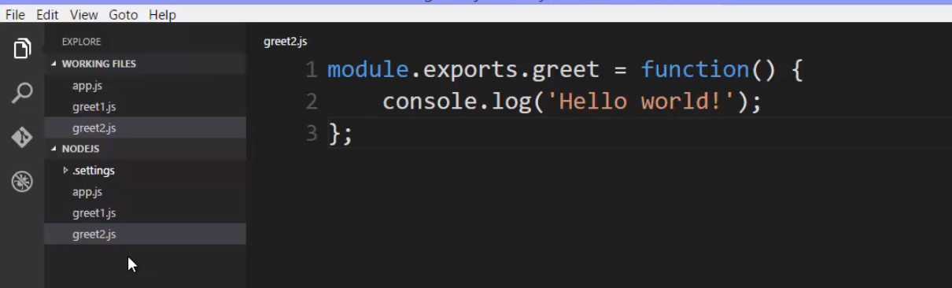

what if I didn't want to have the same object come back from require all the time?

Well I could simply change what I attach to module.exports or what I replace it with.

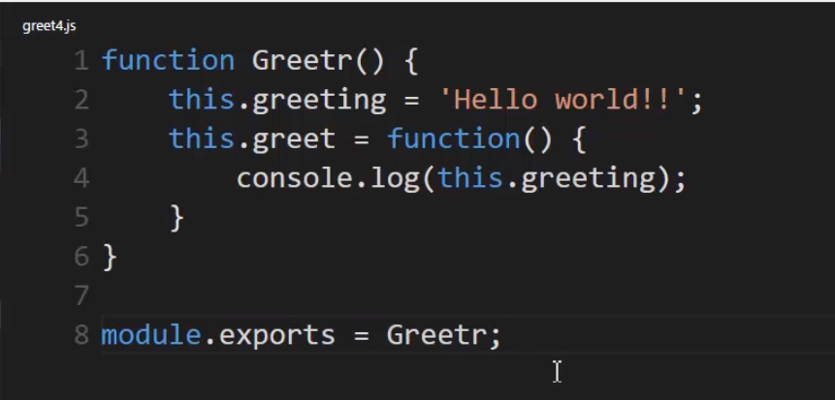

**I'll replace that exports object with the function constructor itself.**

So instead of creating the new object, I'll simply give back for my module, the ability to create the new object.

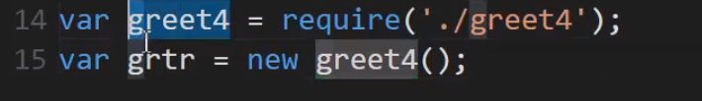

## Important Note :

this actually leads us to something that can cause some confusion when you're using modules in Node.js. Notice that running this code causes module.exports to create a brand new object. That's fairly straight forward.

But here's a question.

What happens if I did something like this? greet3, and greet3b require the exact same file over again.

What will this contain?

A different object, or the same object?

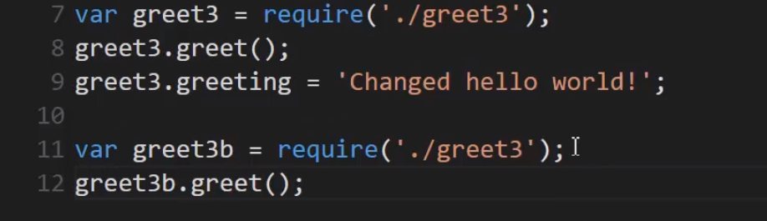

Output - 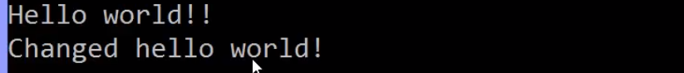

And look at that.

**That fourth one, even though I've called require again, greet3b ended up being the same object as greet3.**

Why is that?

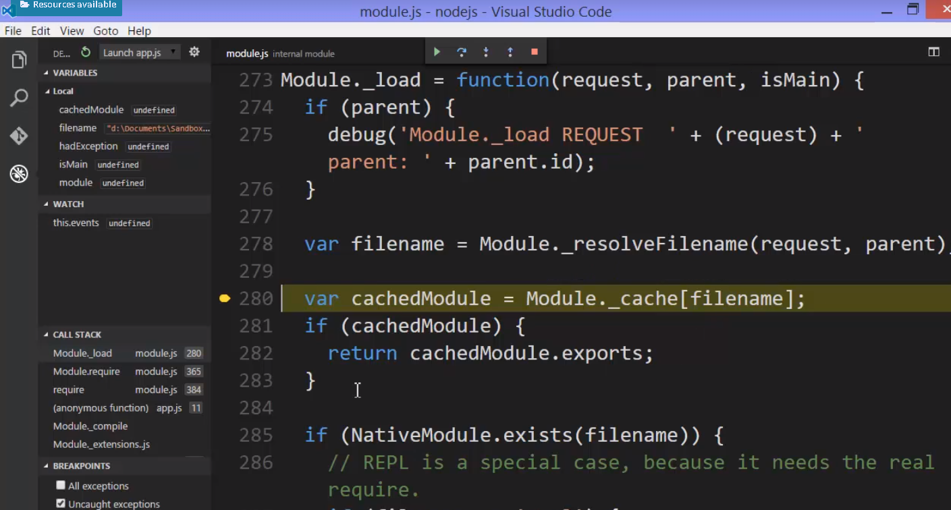

**So the first time Node saw the require function being called for this file name, inside the require function, it cached the results. It cached what came back.**

**That is to say module.exports. It saved it.**

**The next time that I called require using that same file name, it went and said, oh I already know what came back in module.exports from that file and I'll just give you that, and since it's an object, it turns out to be a reference so it ends up being the same object, the same location and memory as the other require function.**

**The change that I made to that object is reflected here as well because both greet3 and greet3b end up pointing at the same object.**

**Note :** **remember that if you simply return an object from require, that will be cached**

**and any other call to that same file via the require function will get you back this same object everywhere.**

**//**



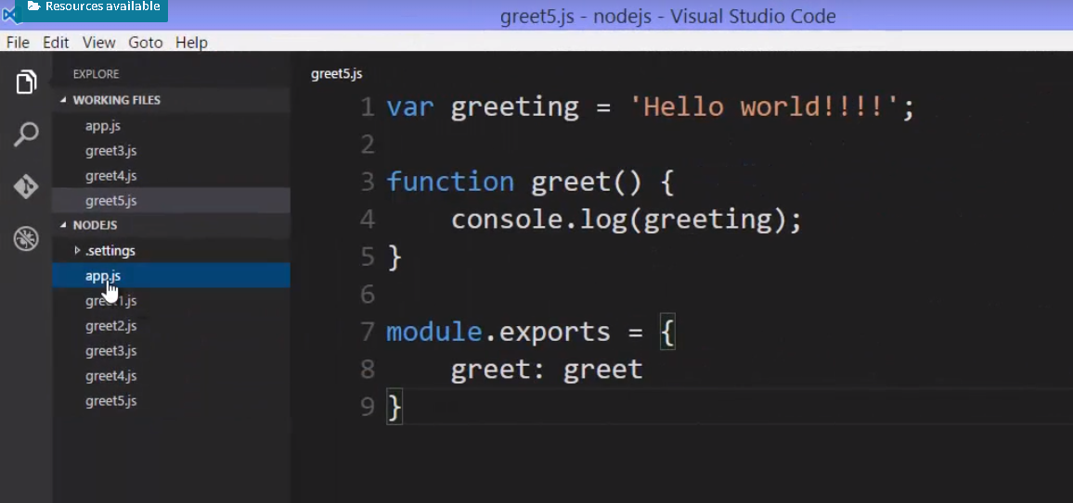

notice there's no way for me to really change the greeting property or access it because it wasn't on the object that was returned. It wasn't revealed to me when I went to use the module via the required function.

**So that greeting variable is protected.**

**//**

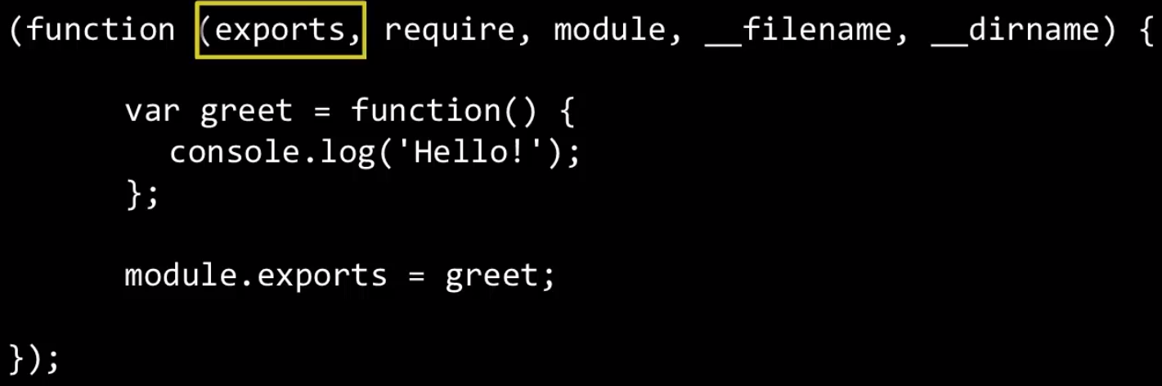

Well, we saw that when the function is executed essentially something like this, these five parameters passed to MyCode, whenever MyCode is run.



The first parameter is module.exports. That's the value passed to the function that wraps my code.

**So really exports, that first parameter, is a shorthand to module.exports. It's two variables pointing at the same object in memory.**

Well, why not just use exports all the time?

Remember that the require function returns module.exports, so it's really returning the property on a module object, and that's a separate variable from that exports variable,

So we have two variables pointing at the same memory space and so in pass by reference they'll be the same thing.

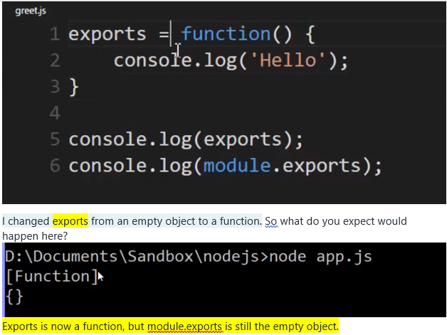

**And what require function return is the exports property of module object. Although both exports and module.exports points to same memory location but now here we have pointed exports to new memory location hence we never assign something to module.exports because that memory location never assigned to anything.**

in JavaScript when a variable is set equal to a value, then it's a new spot in memory. In other words, that reference is broken.

**So when it comes to exports, I can't override it. I can't use equals.**

**However, I can change it. That is to say I can add a new property or a new method. So I can change it. I can what's called mutate it.**

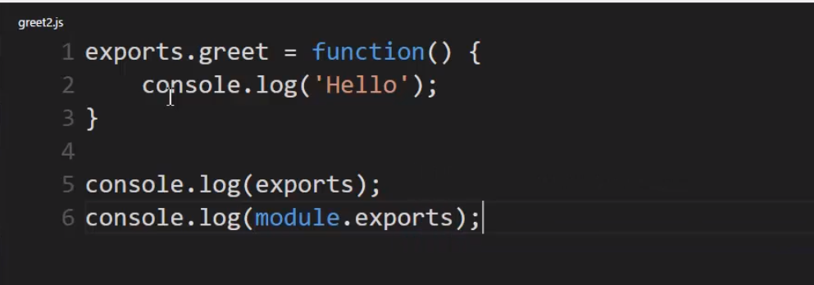

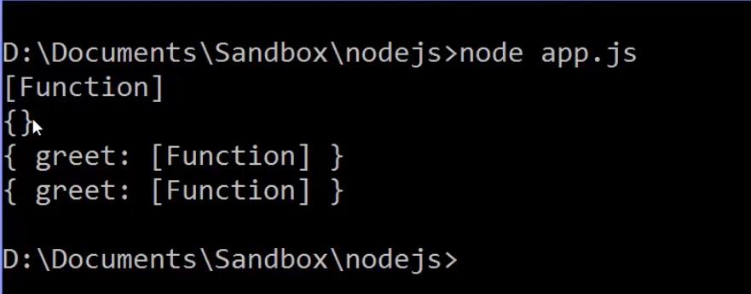

in this case, both exports and module.exports are the same object. See they both have the greet property, the greet method.

So why?

Because I simply mutated. I added, I changed the object, I didn't repoint the variable somewhere, and so the reference held still.

So this is great.

I can use exports if I want to, but only if I mutate the object. I can't replace the object with something else. So you need to be aware of this if you want to use the shorthand.

**Recommentation is to use module.exports**



**//**

**Requiring native modules of nodeJS -**

Require that function does more though than just help you grab your own custom modules.

**Well a native module is essentially the things that you saw in that lib folder. The javascript core. That javascript side of the code that it comes along for the ride with Node js.**

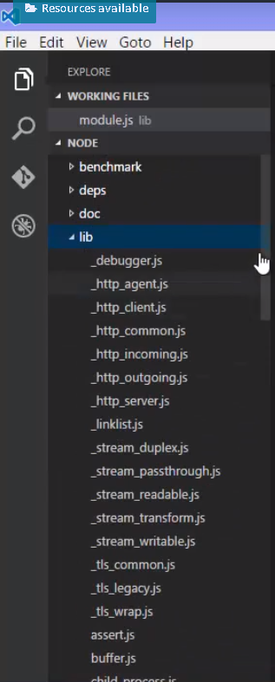

if require sees that the string that you passed to is a native module, it will use it.

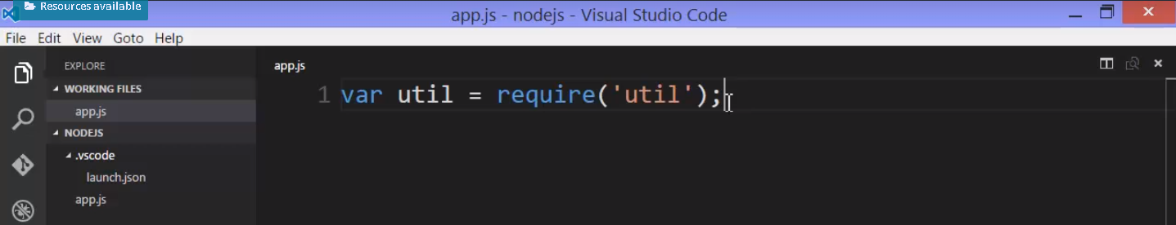

Oh and you might be thinking: what if I name my own custom module the same name as the core js file?

**Well remember if it's custom module you specify the location dot slash or a folder above with dot, dot slash or whatever the case. You're saying that it's local.**

**If you don't then Node is going to look for a native module and some other processes.**

**//**

**Modules and ES6**

NodeJS added the idea, the feature, of modules to JavaScript, because it didn't have it.

The V8 JavaScript engine itself is supporting this concept, not the add-on features from NodeJS.

**So if you see this in code, it's ES6. If you see require and module.exports, it's Node.**

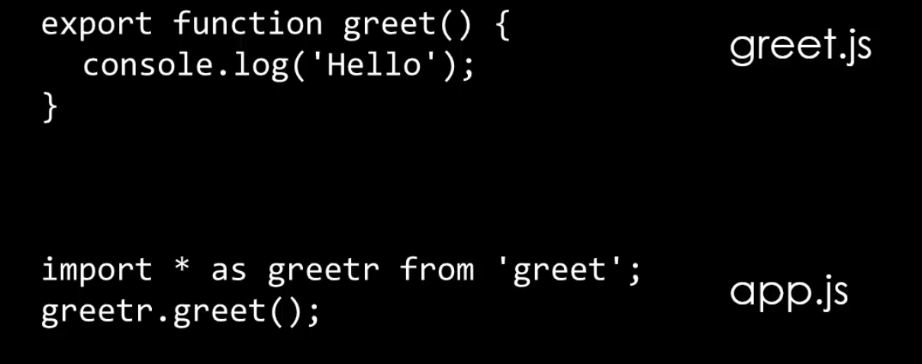

# **Events and Event Emitter**

**Event** – Something that has happened in our app that we can respond to

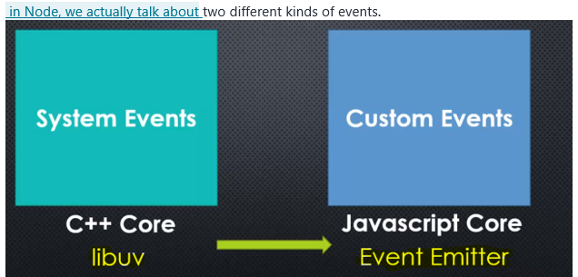

**Libuv** - that's the C++ code, the library of C++ code that's part of Node.js that deals with events coming from the computer system, lower level, closer to the machine.

Like, I finished reading a file, the file is open, I've received data from the Internet,

and other things like that, things that JavaScript doesn't have.

**Event Emitter** - the JavaScript side is faking it, it's not real events. Well JavaScript doesn't have an eventing concept, there's no event object in JavaScript.

But we can fake it, we can create our own event library, our own way of creating, telling the code that something has happened and responding to that something happening

with the technique that the Node event emitter uses.

//

**Lets first try to create our own Event emitter**

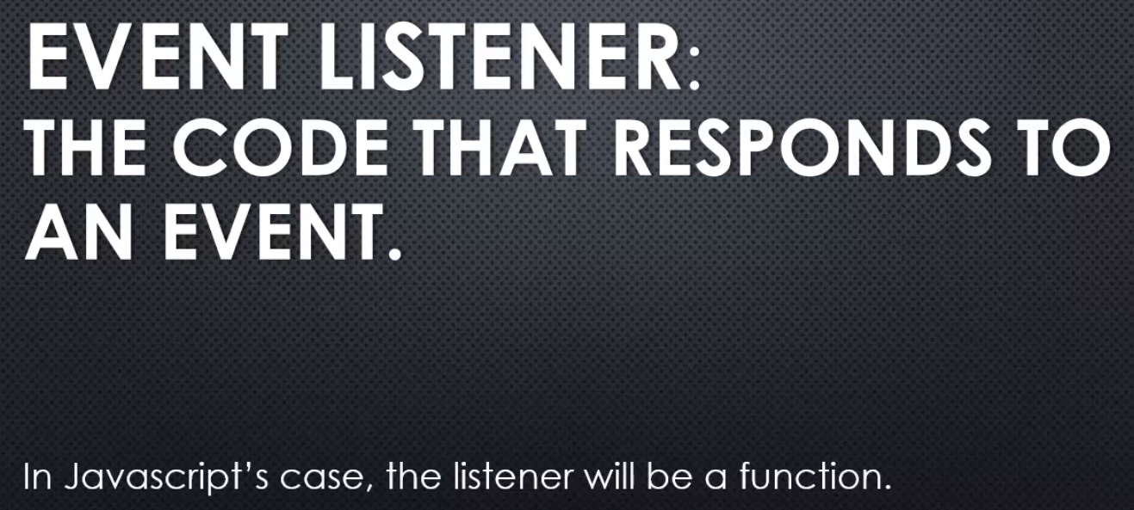

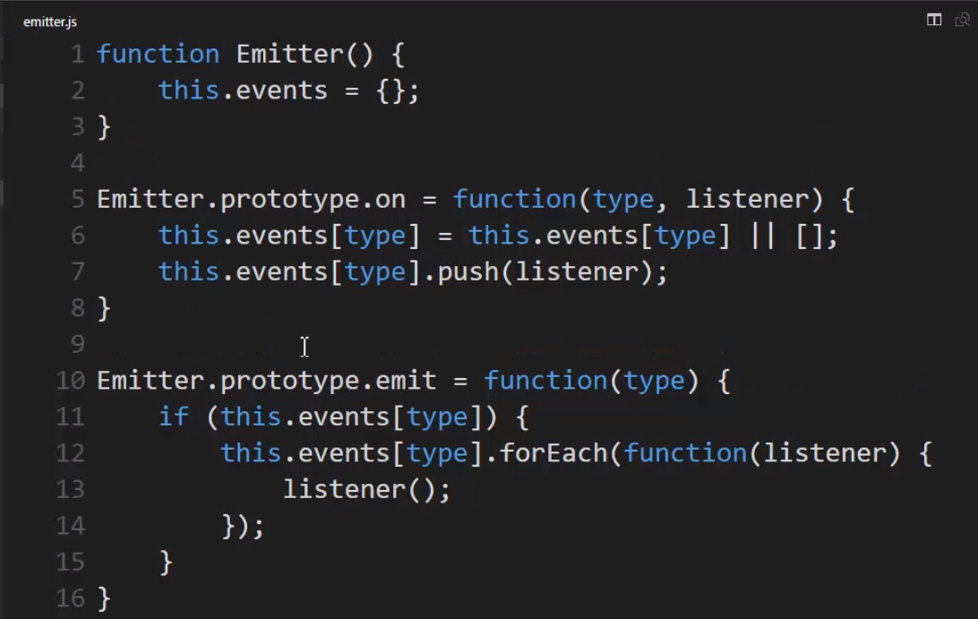



Another way for For each –

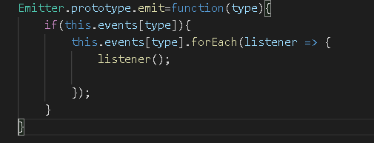

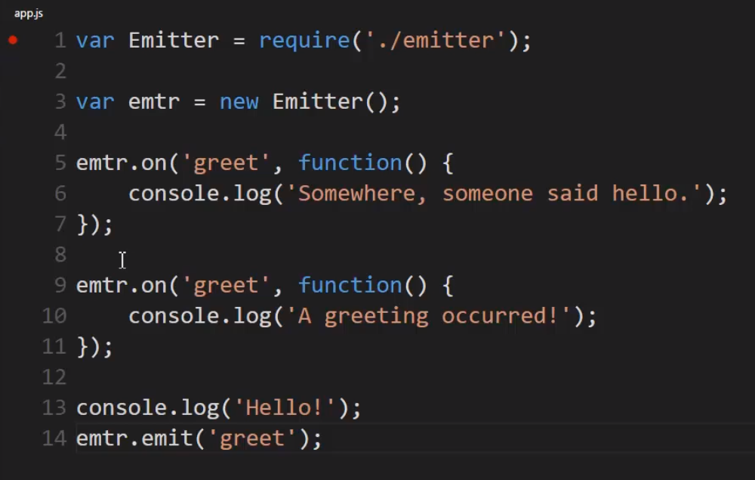

**This will run whenever the greet event is emitted**

**I manually emitted the event. And what emit does is just finds this property and loops through the array, and runs all the functions in the array**

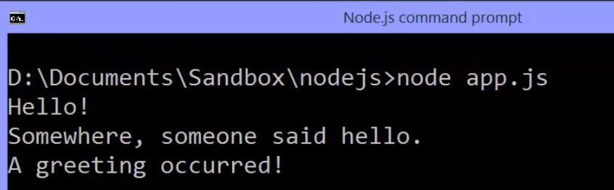

When you debug it - 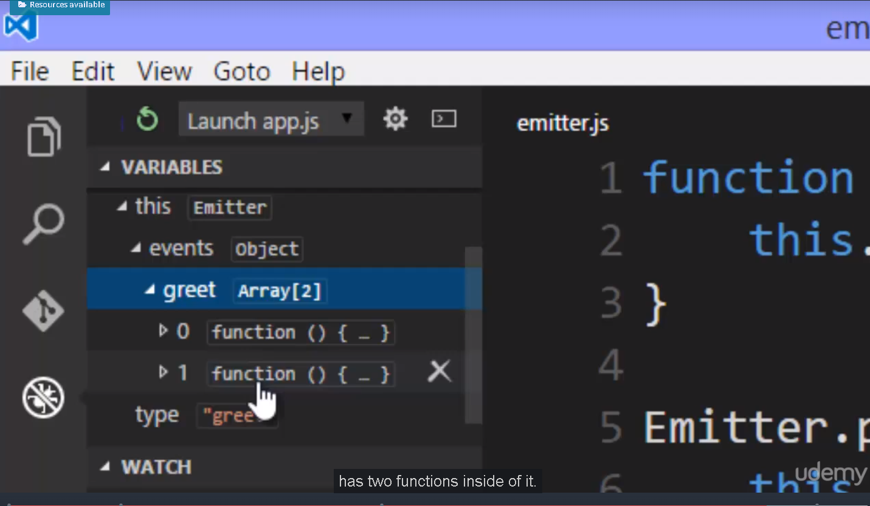

**Node Event Emitter**

**Let's look at the Node Event Emitter.**

**Lets look at the nodeJS official api documentation.**

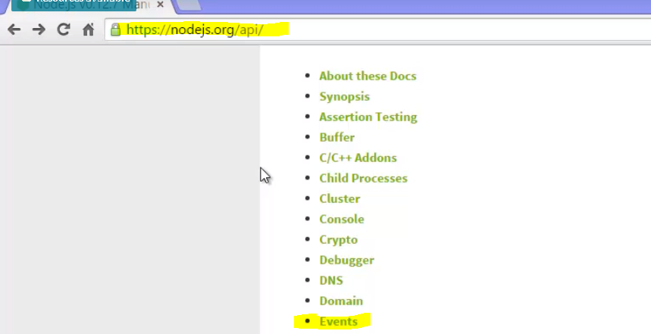

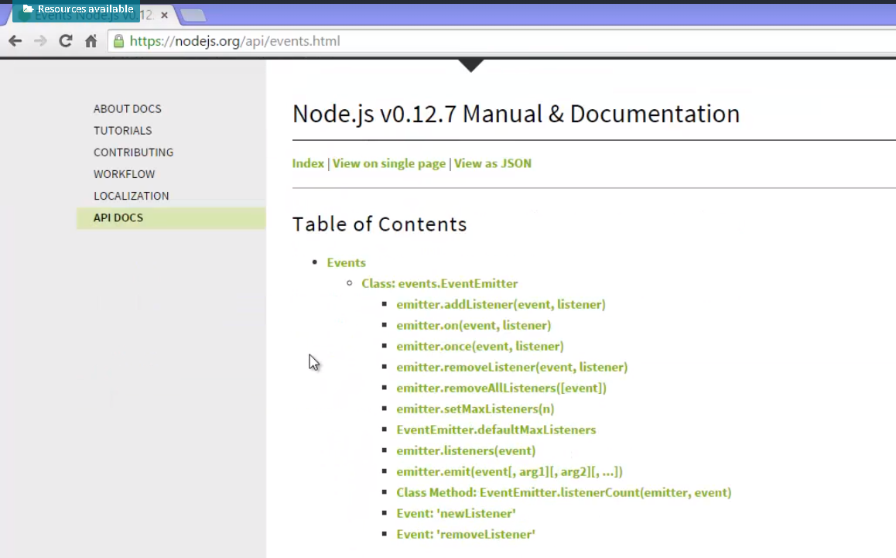

**Lets use nodeJS native events module -**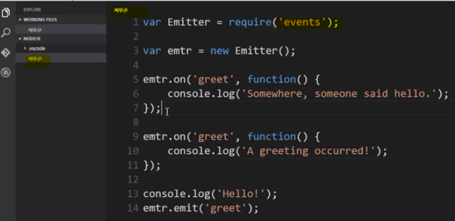

**There's one problem with this trick when it comes to the event emitter. It relies on what's called magic strings.**

We mean a string that has some special meaning in our code. You have an if statement that says if the string equals this, then do this. And that's essentially what our event emitter is because we give it a string, and that determines the property on the object we're looking for.

**This is bad because it makes it easy for a typo to cause a bug. I type the wrong string, and suddenly it doesn't work. And worse because it's hard for tools like Visual Studio Code or others to help us find that bug because it's just a string. It's not a variable. So, any tool that we might be using can't just tell us oh, I don't recognise that variable.**

So there is a few ways to deal with that.

Let's quickly show you one way to deal with strings in this example, for events.

Let's fix the fact that we're relying on this string for our event emitter to function properly. We still will need the string, but let's remove the fact that we're relying on typing it correctly, without any kind of help from the debugger, or from a tool. Now you don't have to do this.

**Lets create a config module, and each event that I can have in my application will get a property on this object.**

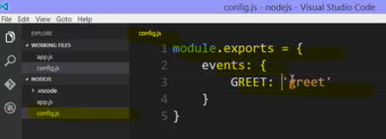

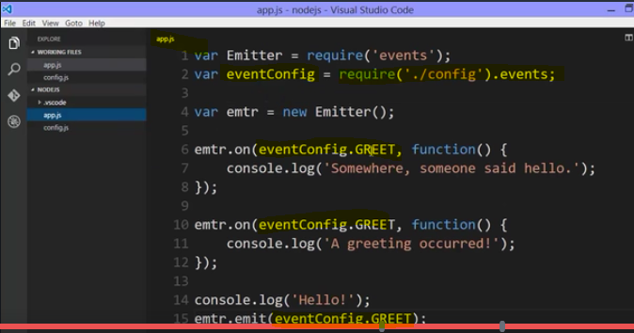

**then everywhere I had greet, I can use that property name in place of the string because that's its value. Remember this is just a string value, so that string is what will be passed here. And also notice, that because I'm now using variables and properties, tools like Visual Studio Code are able to help me grab those property names. So this works out a lot better for me, because it helps me avoid accidentally mistyping the property, and if I did type it incorrectly, the error I would get would be more helpful. That this property doesn't exist on that object, or that it's undefined. it still works the same way, and I'm still just passing strings, but I've gone and centralised the strings themselves, and then used those properties everywhere.**

**Inheriting from Event Emitter**

There are a number of ways to set up the prototype chain in JavaScript, that is inheritance in JavaScript. We've seen function constructors where the .prototype property of the function is what all objects created from that function constructor point to as their prototype. There are ES6 classes and a keyword called extends, and we've seen object.create.

**Within util.js, the util.js file, that module inside the Node.js source code, there's something to help us with inheritance. It's a method called inherit, and it takes two constructors. A function constructor, upon which you want to add new methods and properties to be available to objects created with it, and another constructor, where, that's where the properties and methods you want to be added onto your objects, made available to your objects are sitting,**

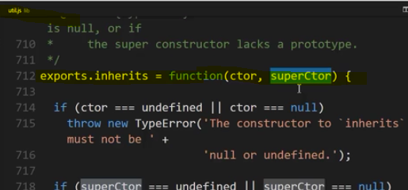

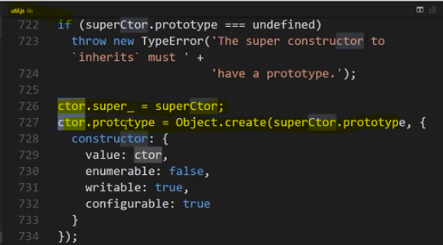

Alright, let's see this practically by inheriting from the event emitter.

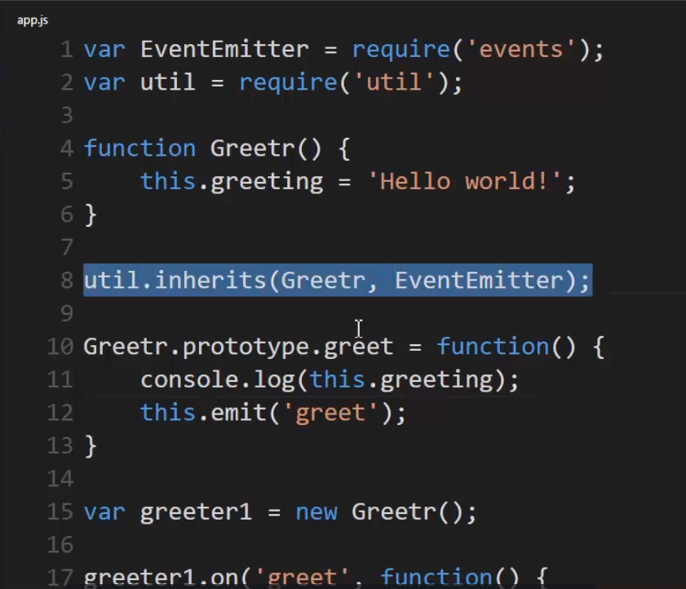

I'll say that any objects created from Greetr should also have access to the methods and properties on the prototype property of EventEmitter. So, essentially, any new objects I create from Greetr, will also get all the EventEmitter methods and properties, and I can still add my own extra methods and properties

lets run above code - 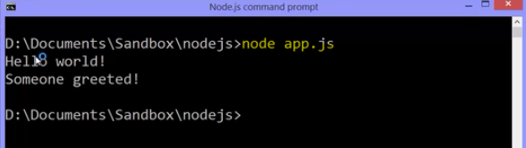

Now, I emit the event and if I want to pass this data to all my listeners, to all the functions in that array that will be invoked,

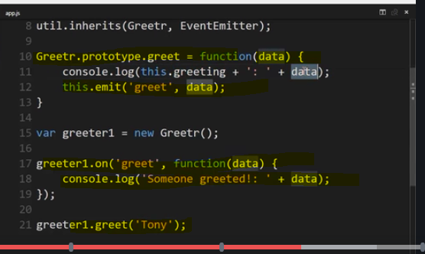

Lets understand what happens behind the scene visually

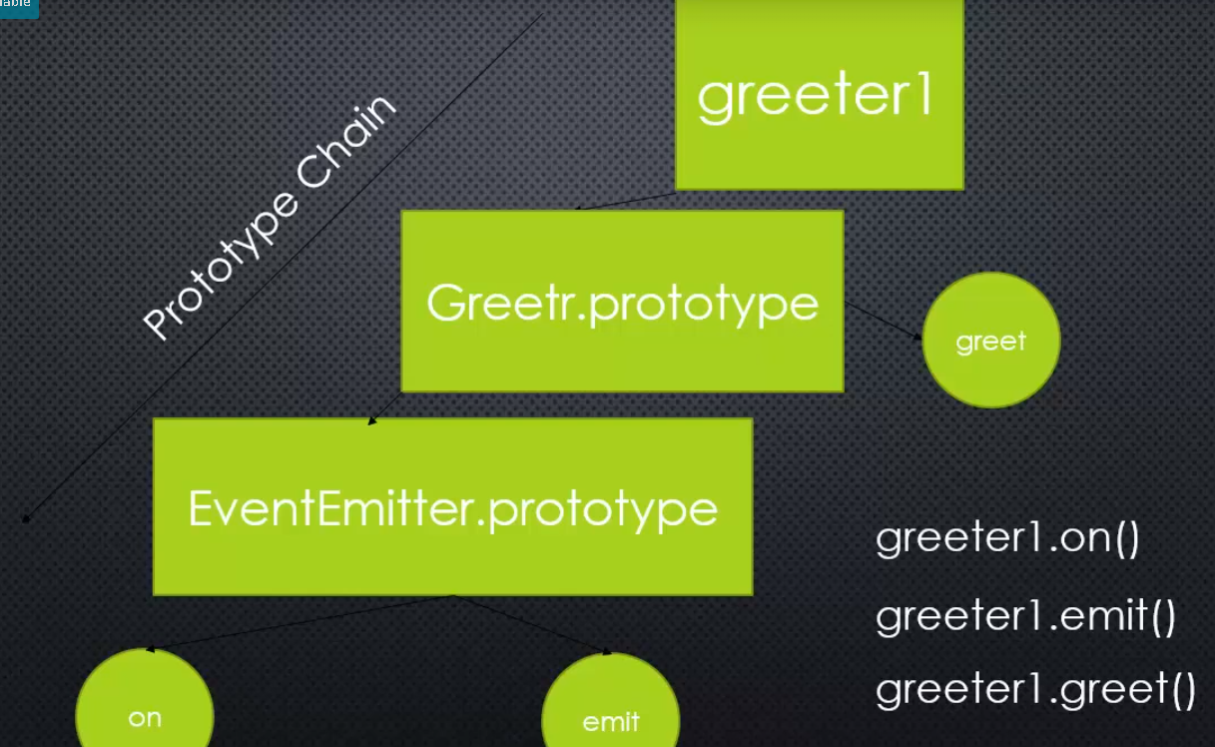

**Well, we had this object. It's sitting on the prototype property of the EventEmitter function constructor. So, any objects created from that EventEmitter function constructor will point at this object as their prototype, and it has some methods on it, some features that we want, like on and emit.**

**but we don't wanna just create an EventEmitter, we wanna create another object that does more than what the EventEmitter does, but also does what the EventEmitter does.**

**So, we used util.inherit**

**we're going to see other objects, key objects, in building software applications in Node that allow you to listen for and emit events because they have the EventEmitter down their prototype chain.**

**That is to say, many objects built into Node are a type of EventEmitter. They emit events and you can listen for them, run code, when a particular event happens.**

**//**

**the latest version of Node includes the latest version of V8 embedded inside of it. And the latest versions of V8 have more support for ES6.**

**//**

there's one scenario that we haven't covered.

**Inside the function constructor, we can add properties and methods directly onto**

**the object being created, as opposed to properties and methods on the prototype.**

**The this keyword is the new object being created whenever I say new and then function constructor. So that's how I add properties and methods.**

But what if EventEmitter, or whatever else I'm inheriting from also adds properties and methods directly to the new object, not necessarily the prototype?

Inside my function constructor, I'll say EventEmitter.call(this).

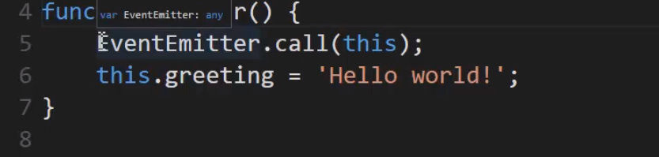

Now what does that do?

**Well EventEmitter is a function constructor. And so when it's invoked with the new keyword, the this variable points to an empty object and it adds on properties and methods.**

**But I'm overwriting what the this keyword is. So I don't need to use the new keyword. All I need to do is say run the function constructor And pass the new object that has already been created, then inside the EventEmitter function constructor, I'll have a bunch of properties and methods added if there are any to it.**

**And because this is passed by reference because it's an object, then I can just keep adding on my own properties and methods to that new object.**

**basic idea is simply this in JavaScript. I'm using .call, I could also use .apply in order to give it the new object that I'm working on so that it does it's work of adding properties and methods to that new object. So the this keyword inside the EventEmitter will be the same this inside Greetr, add all of the properties and methods, add my properties and methods, and then the prototype chain is still set up the same way.**

So this one line of code ensures that my object created from this function constructor has everything an object created from an EventEmitter would have.

**//**

**Inside JavaScript, class is just really syntactic sugar. It's essentially a function, and the constructor keyword and those properties and methods that you're putting on the prototype, that's all happening behind the scenes, and so you're separated a little bit from what's really going on. You don't even see the concept of prototype in the syntax.**

**With ES6 Classes**

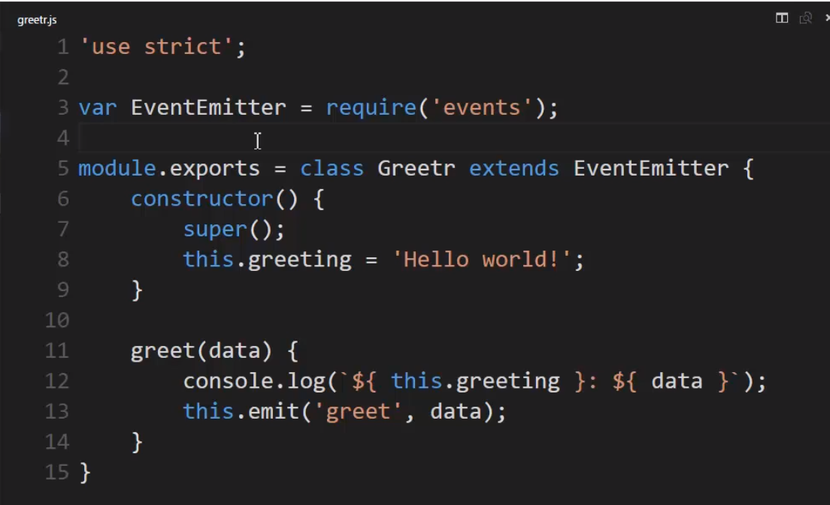

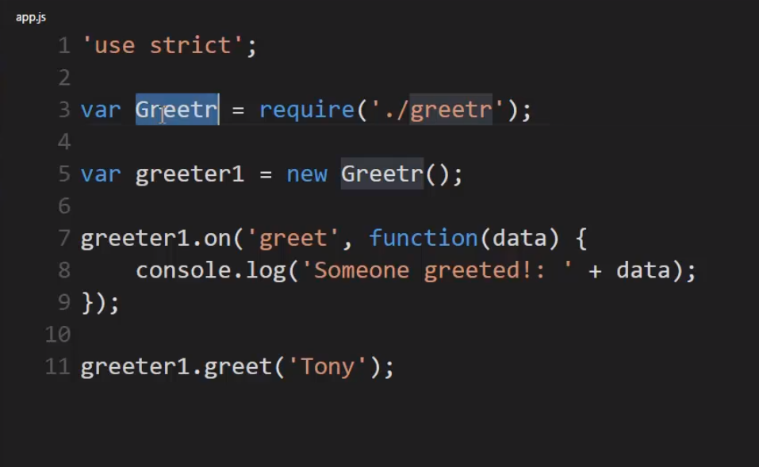

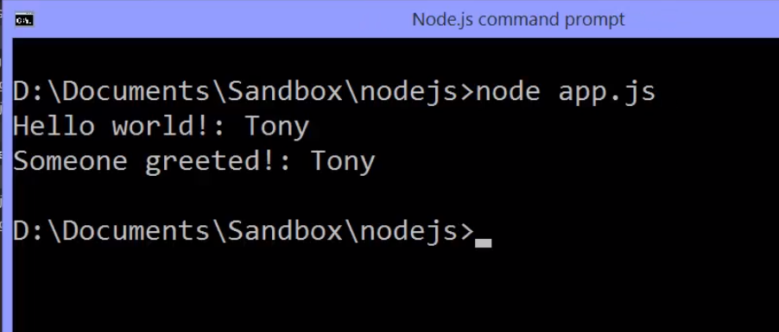

# **LIBUV , the event loop and non-blocking asynchronous code**

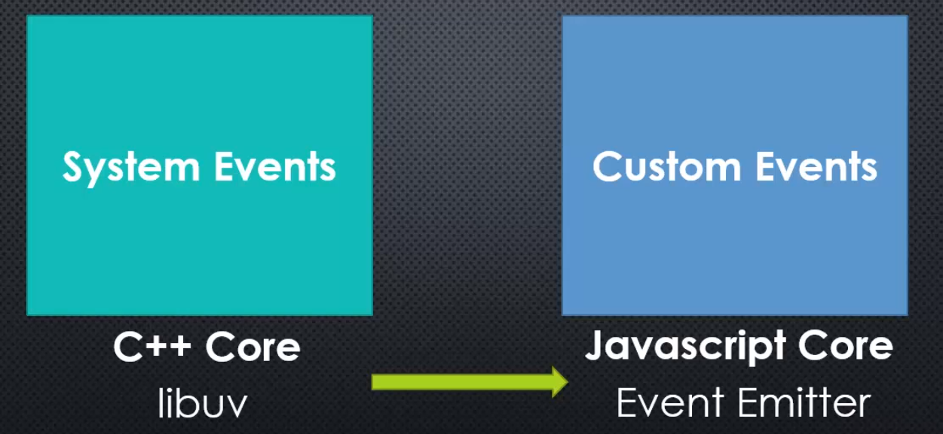

**System events, handled inside the C++ side of the core, are actually handled by a C library called libuv, that's also embedded inside Node and is used elsewhere.**

**The idea here is managing events coming from the operating system closer to the machine.**

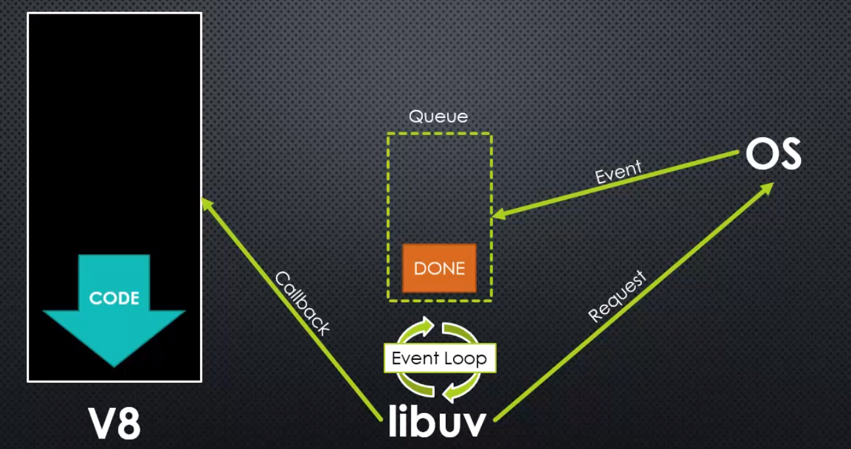

Inside Node, we have V8. JavaScript is synchronous, so V8 runs one set of code at a time, essentially one line of code at a time, and finishes that execution, and that keeps happening as functions are called, etcetera.

**Now, also inside Node, is libuv, another library. This one written specifically to deal With things happening lower level, events occurring in the operating system.**

**Libuv connects by requesting something from the operating system. Let's say it requests to download something from the internet or to open a file, and libuv inside of it has this queue, a queue of events that have completed.**

**This may be happening simultaneously while V8 is running its code.**

**Inside libuv, the most important part is called the event loop, and that's a loop in which libuv is constantly checking the queue that something has happened. This, again, is happening while V8 is running.**

**Then, at some point, the operating system, and this may take a while, depending on what you've asked of your computer to do, to download a large amount of data, to open a file, whatever the case is, or perhaps the internet connection is slow. Whatever happens, it's an event, and that event will get placed in the queue from the operating system. There may be more than one between checks, as the loop is looping.**

**On every loop, libuv checks the queue, and the operating system may put more than one, "Hey, I finished that" inside there.**

**When, while checking in that loop, libuv sees that something is complete, it processes it, and it runs a callback**, that is to say code that is meant to be run when that event completes, it's some code that we've said, "Hey, libuv, "this is code that should run when this other code "is finished running," and so we call it a callback. It's very similar to the idea of an event listener.

**That callback ultimately will involve, and usually internally, JavaScript code running as a response, but only when it's finished running any other code that it's running because** **JavaScript is synchronous, so it can only handle one thing at a time. JavaScript code may be running currently, and an event comes from the OS, libuv, checking the event loop, sees that it's complete and tells V8 to run some code, but V8 will wait to run that code until it's finished running the code that it's currently running because it's synchronous.**

**This entire process is asynchronous, because there are things happening in libuv and V8 at the same time, and all of this inside Node itself.**

## **Event Driven Non-Blocking I/O**



When we talk about Node, sometimes you'll see a tagline that looks something like Event Driven Non-Blocking I/O in V8 JavaScript.

We understand that V8 is embedded inside of Node, and that's what's executing the JavaScript code.

**when we talk about I/O, or input/ouput, that these are things happening at the operating system level, opening files, connecting to databases, and retrieving and sending information over the internet. These things happen at a core level within your computer system, and within a server.**

**so the event driven part is where we're asking for these things to happen and then we're getting an event notification when it's done, so we get this event in the queue, the event has happened, and the loop is constantly checking for that, and because your code, your JavaScript code, can continue to run, this is called non-blocking.**

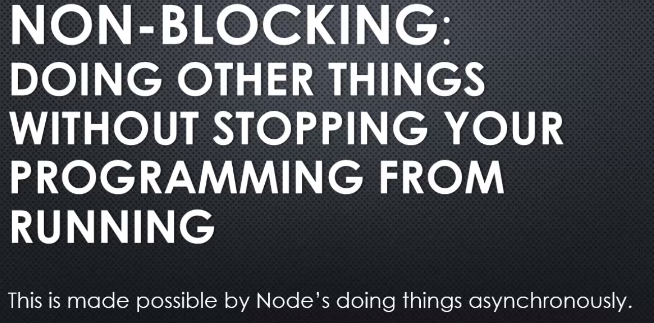

**blocking process means that, for example, let's say I said, "Go grab me this file please "and get the contents," and then I waited for the entire file to be read and all the contents to be pulled into memory, and then I moved on to the next line of code. The problem with that is as you get many users, and perhaps there is a variety of times that it takes for these things to occur, maybe the server slows down for some reason, maybe the file's extremely large, then you would end up blocking the next thing that you can do in your programme. Your programme would essentially seem to freeze while it's carrying out these other tasks.**

**With the non-blocking approach with Node, we ask Node to go off and do something else, and our JavaScript continues running, our programme continues running, and then, when the next time it is available, when the V8 engine is no longer busy, if an event has occurred, then libuv, within the node architecture, is used to run more code in V8 functions that we want to run internal to Node, and then the event emitter also lets us run our own code, because usually those events coming from libuv are also related through the event emitter, the JavaScript side, they cause a JavaScript event, so that we also can add our own functions that we want to run when something has happened.**

**so Node lets us write synchronous code in JavaScript that's very easy to manage, and still respond to things that are happening asynchronously.**

**we simply say, "Please run this code "when this thing over here is done, "and meanwhile, we'll keep running "this other code over here."**

## **Why NodeJS is high performant?**

**so that's the idea of the event loop and non-blocking event driven architecture that is at the core of Node.js, and what helps Node.js be very performant, high performance, because many people can ask for the server to do many things, and we won't block; we'll keep running JavaScript, and people can keep coming in and requesting things to happen, and as things finish, we respond.**

**Libuv** - **asynchronous I/O made simple. In other words, as we said, helping us to manage more easily when multiple things are happening simultaneously.**

**it's a module that was built primarily for Node, but can be used elsewhere.**

## **Streams and Buffers**

**Buffer** - We store it there and it's temporary. We'll move data into a buffer then move it out and move new data into a buffer. But **it's really just a spot in memory**.



**Stream –**

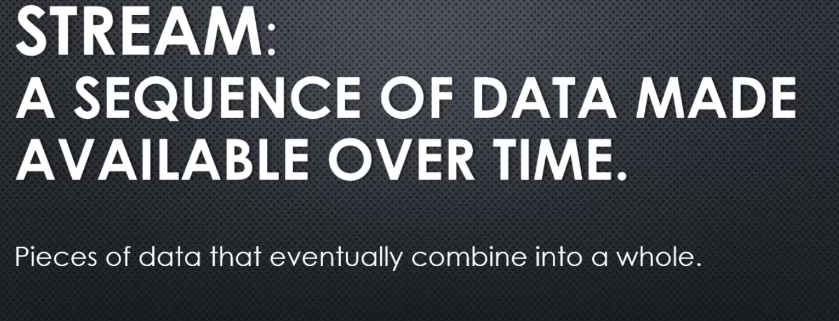



**And a lot of times, we actually are combining the idea of a stream and a buffer.**

**Data comes down the stream, a certain amount of data is gathered into the buffer, and then that is processed. And then, it happens again, as we continue to get data until the stream is done, until the data that's trying to be streamed is complete.**

## **Binary Data , Character Sets and Encoding**

**And because each place we're calculating based on two to the something power, we call it base two. That's binary.**

binary only needs two digits to represent numbers.

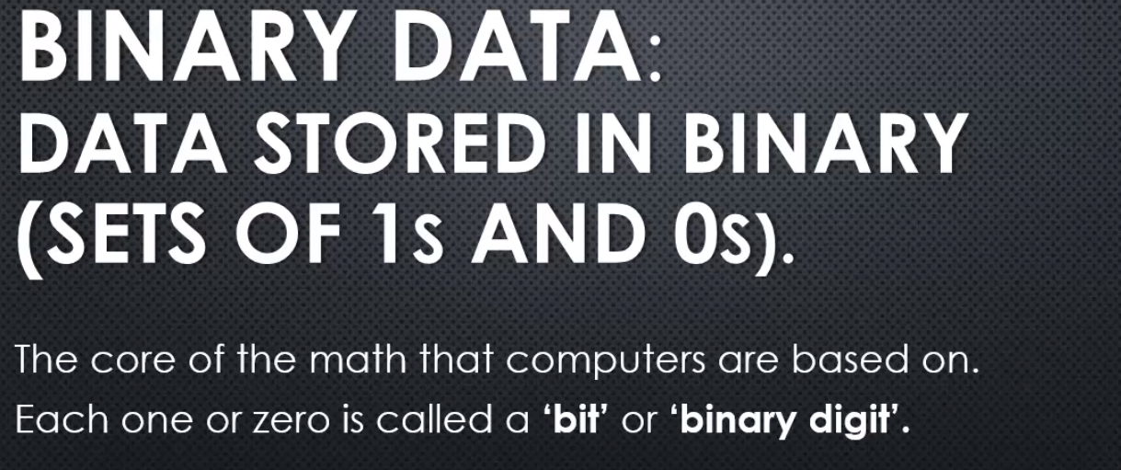

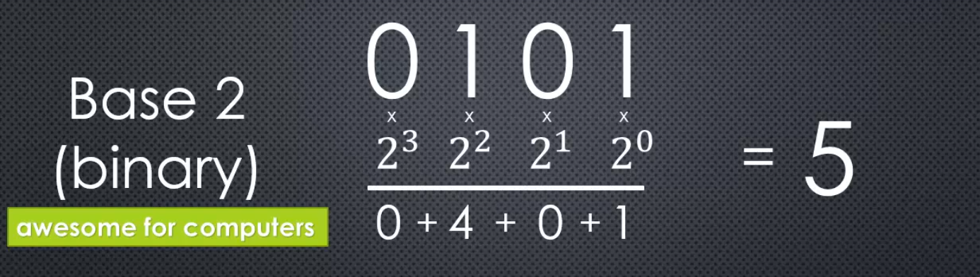



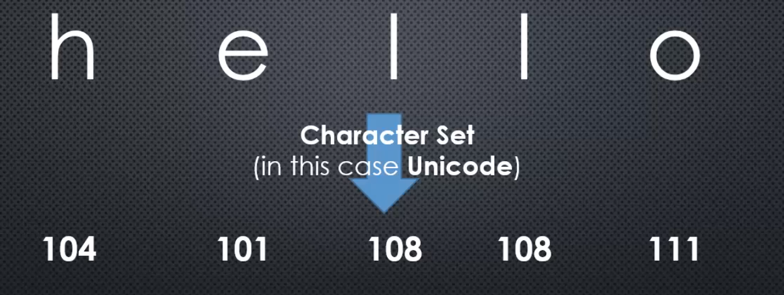

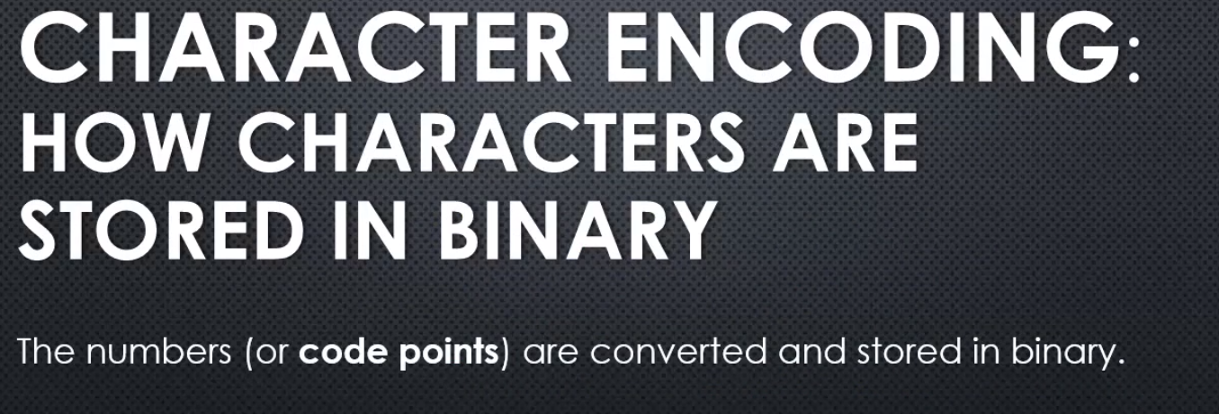

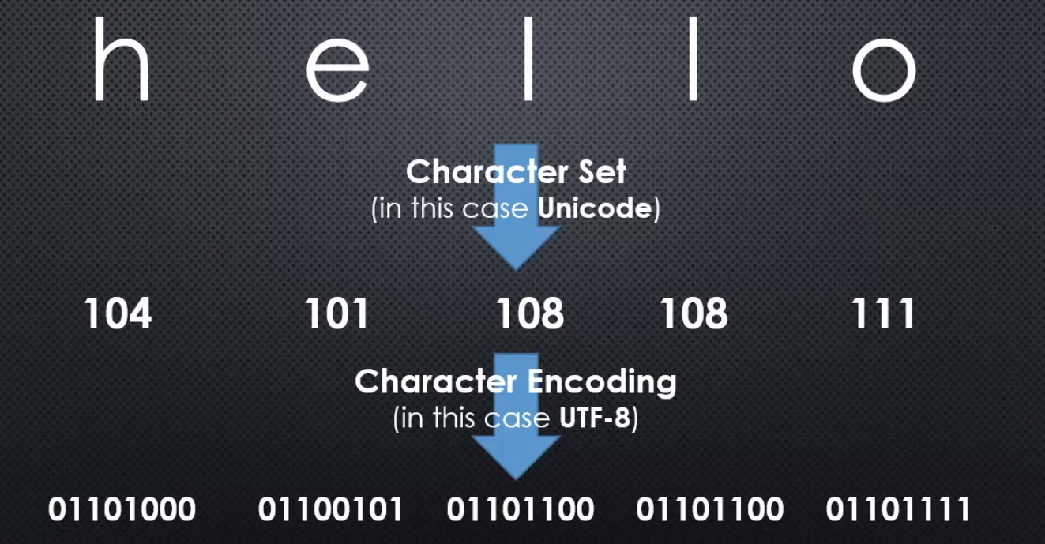

**In this case, UTF-8, we have eight bits, eight digits to represent a number. You can see that each number gets eight bits available to it, even if it doesn't need all of them. Even if there zeroes to the far left.**

**And the reason is, because the more bits, the more digits we have, the bigger the number we can represent.**

**character sets**- what number is each character represented by. We assign each character, letters, and symbols, a number.

**Character encoding** - means how many bits are we using to store that number. The more bits, the more characters we can store because the number is bigger.

**historically, JavaScript is not very good at the encoding part. JavaScript handles Unicode okay, translating letters to numbers, and back and forth, but the pure raw binary data, JavaScript doesn't have a lot of features to deal with.**

**And so because of that, Node, with V8, the engine embedded in it, expands on the JavaScript language, and gives us some mechanisms to deal with binary data. Raw zeroes and ones.**

## **Buffer in NodeJS**

Go to Docs and then the API and we can look at the built in buffer object.

The buffer is created on the C++ side of the Node core and then made available to the JavaScript side.

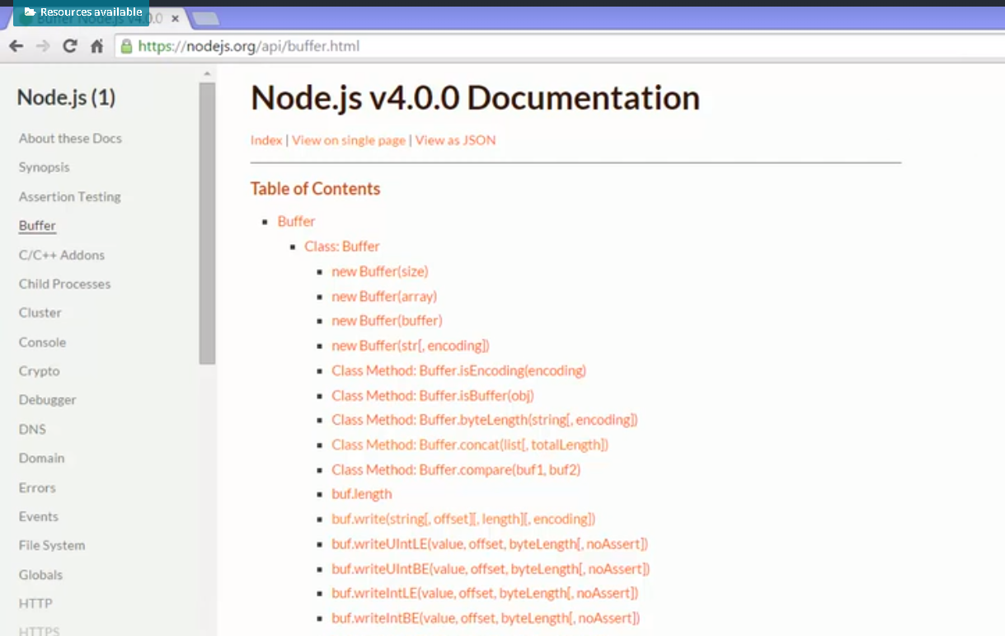

I'll create a variable and make it a new buffer. because buffer is such a fundamental concept within Node,

Instead, nodejs made it global. globally available to JavaScript.

However, we do have to give it some data. So I can either make a buffer and say the size because the buffer is intended to be a particular finite size, particular amount of memory or I can just give it some string value and I can specify the encoding. Now if I don't specify the encoding, if I leave this off, utf8 is actually the default.

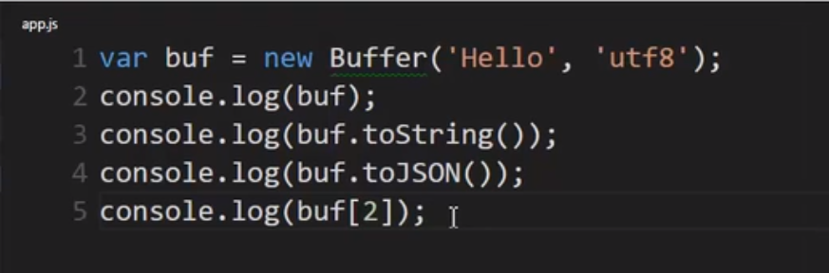

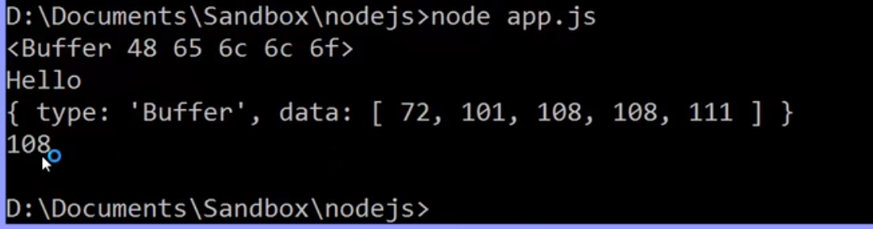

**The buffer itself behaves rather like an array. So I can actually go out and use brackets to get a particular one of those numbers.**

 I can also write data to the buffer

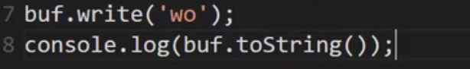

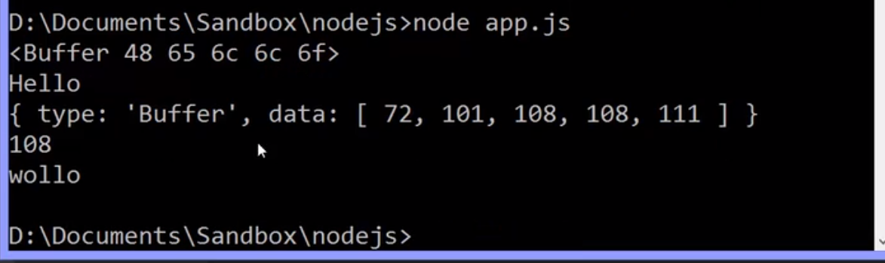

So when I wrote the buffer since I initialised it to allow for five characters, it overwrote those two. It didn't expand or stretch, it simply started overwriting the data in the buffer.

**Because the expectation is that as things come into the buffer, we pull them out when the buffer is full and process it and keep putting things into the buffer.**

## **Files and fs**

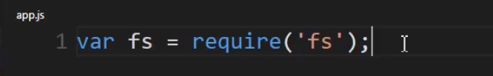

using require to get the built in fs module.

**That's fs.js inside the node source code on the JavaScript side of the core, and that deals with the file system that wraps up the C++ code that lets me get lower level and deal directly with files.**

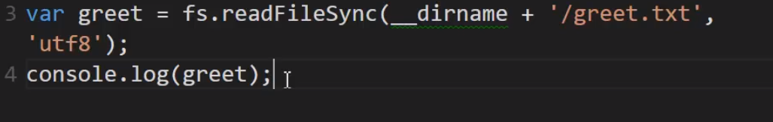

**Now, we're dealing with files on our operating system; so that means we're dealing with, normally, binary data.**

**So I need to be able to deal with binary data in reading the file.**

So I'll call **fs.readFileSync.**

**it will read the binary data, and then it will use the encoding to determine what those zeros and ones mean, what they ultimately map to as characters.**

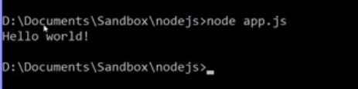

this is a **synchronous approach** to reading the file. That means that when this line of code is run by the JavaScript engine, it will wait until the buffer is filled and it has the string back before the V8 engine will move on to the next line of code.

**Now, this can be useful when, for example, you're setting up initially your application, the first lines of code. Maybe you have a configuration file of some kind and you need to read that before any other code can run. That's a perfectly valid reason to wait until the file is finished reading in order to move on to the next line of code.**

**But in most cases, you don't want this to be synchronous because perhaps you have many people requesting information from your node application; and if you have many simultaneous users, what's going to happen is they'll all end up blocked because JavaScript is synchronous even though node is asynchronous.**

**asynchronous method of handling this by node.js – readFile()**

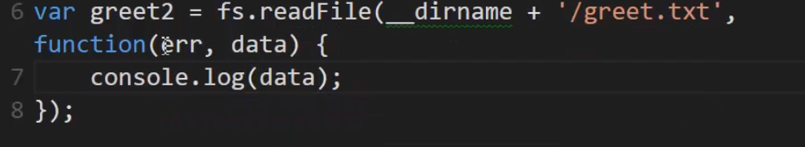

Output -



**so what comes back, by default, is a buffer. remember, it's loading binary data; so that's what it gave me, a buffer full of the binary data. A buffer full of the contents of that text file.**

**Now I could convert this using the buffer to string, or I could just say, as my second parameter, the encoding that I'm expecting this to be, this file. If I include that parameter, then it will convert the buffer to a string and give me back the string.**

**ultimately, what happens is it goes off and says, all right, C++ code, do your thing.**

**Libuv will go and ask the OS to do the work, and then when the event is complete, when it has finished reading the file, please run this JavaScript code.**

**The JavaScript will be running through V8 while simultaneously I'm asking node to go and read the contents of this file. And thanks to the event loop, I will simply have this function invoked when that work is complete and V8 has nothing else that it's doing.**

this is popular pattern in node called error-first callbacks. 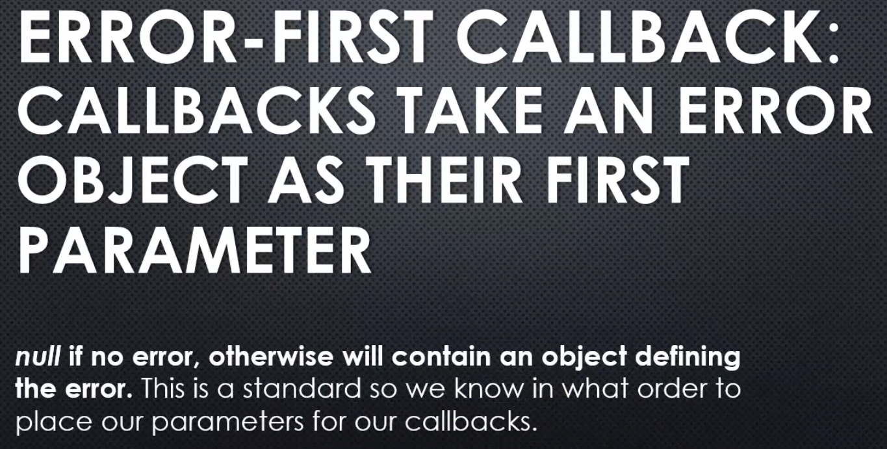

**Now, we actually have one other problem here. The problem is that this is using a buffer to load the file contents, and a buffer is just data sitting in memory. It actually sits on what's called the heap in V8, meaning that it's just a spot where data sits, where data that the application is using; and so node sticks the buffer contents onto what's called the heap in V8, meaning the memory space that the JavaScript engine is using. If that file is very large and many people are running this programme, you'll end up with many buffers that are very large in size; and so all of a sudden you'll end up having problems in your application using a lot of memory.**

**This is a real problem. You could end up causing yourself a lot of grief when you actually put out your application in the real world. So we need a way, now that we've seen we can do it asynchronously for performance, to also minimise how much data we're working with at any one time inside the buffer.**

**To solve that we have a concept of chunks in streams, lets see what it is**

Streams is a sequence of pieces of data, data that's broken up into what's called chunks.

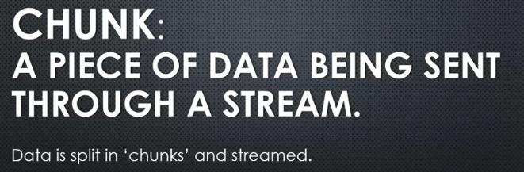

**So we take our data, we take our information, split it into chunks of some particular size and send them down the pipeline between whatever two points of communication are trying to send the data between.**

Let's take a look at the prototype chain of Streams in nodejs

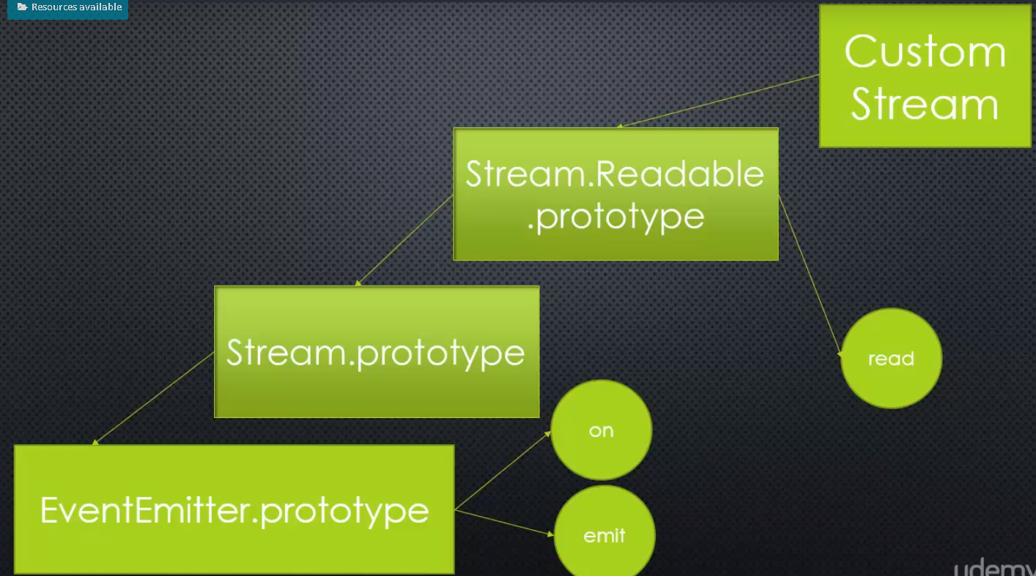

**since Streams are abstract, we never work with them directly. Instead, custom streams for particular purposes.**

Since streams are abstract, we never work directly with them, we need to look at a concrete implementation in order to actually try this.

The perfect spot to try this out is file system (fs.js). inside the fs module, the files module, there is a function called createReadStream.

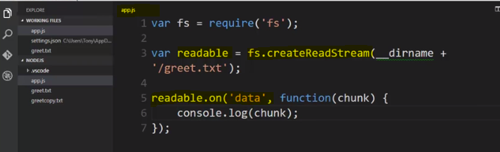

**Fs.createReadStream gives me ReadStream object. And because it has EventEmitter down the pipeline, I can listen to an event.**

**an event that's emitted by the ReadStream is data on data.**

**Now, if the contents are the same size or smaller than the buffer, then you'll just get all the data, but if this text file is bigger than the buffer size, you'll get pieces of the text file at a time, where each piece is the size of the buffer.**

**every time it emits the event and runs the listeners, it will actually pass the data that was in the buffer to the listener**

**Output -** 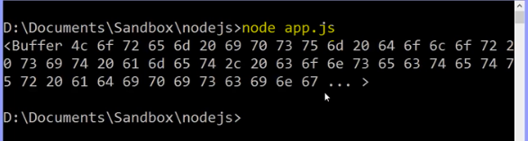

get strings instead of buffers, I will give parameter encoding

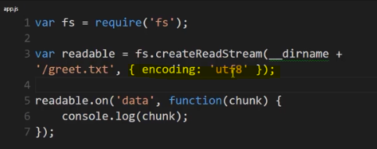

**Output -** 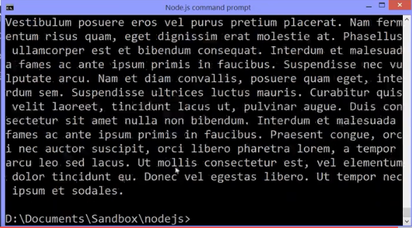

**there's actually an option called highWaterMark, and this is actually the number of bytes that we want our buffer size to be**

**So I'll just say 32 times 1024, since this wants bytes. I want 32, and this is bytes, 1024 bytes per kilobyte. So this is 32 kilobytes.**

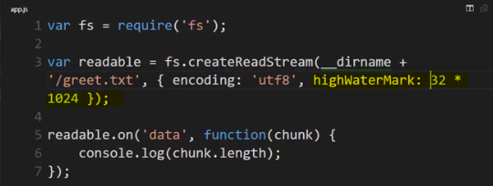

Output- 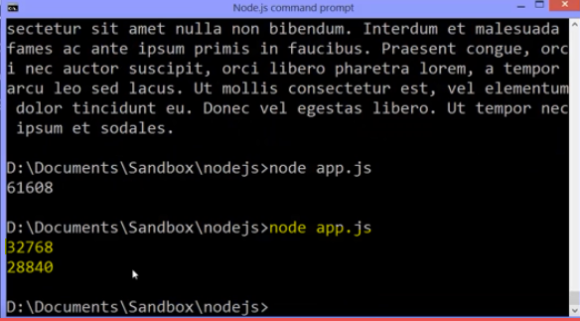

There, see the two chunks? 32 kilobytes, and then the rest.

**Now lets create a writable stream and copy(writing) the chunks that we received in new file.**

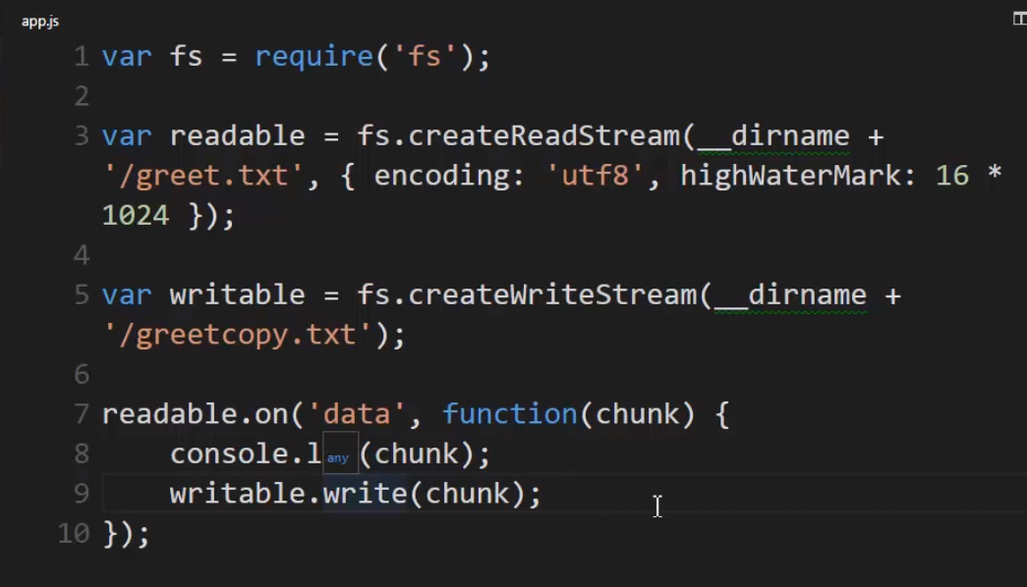

I can just say writable.write and send that chunk to the write stream, and since it's a file writing stream, when it receives that chunk, it will simply write it to the file.

**I just copied the files by listening for the data event, because a stream is an event emitter, and sending the data to the writable stream a piece at a time.**

**It also means I didn't need a massive buffer in order to work with the file. I didn't need to read the whole file in at once. I could send it in pieces and minimise the amount of memory that my programme, my application is using, on the server.**

## **Pipe**

**that's so common that there's actually an even faster and better way to do it within Node.**

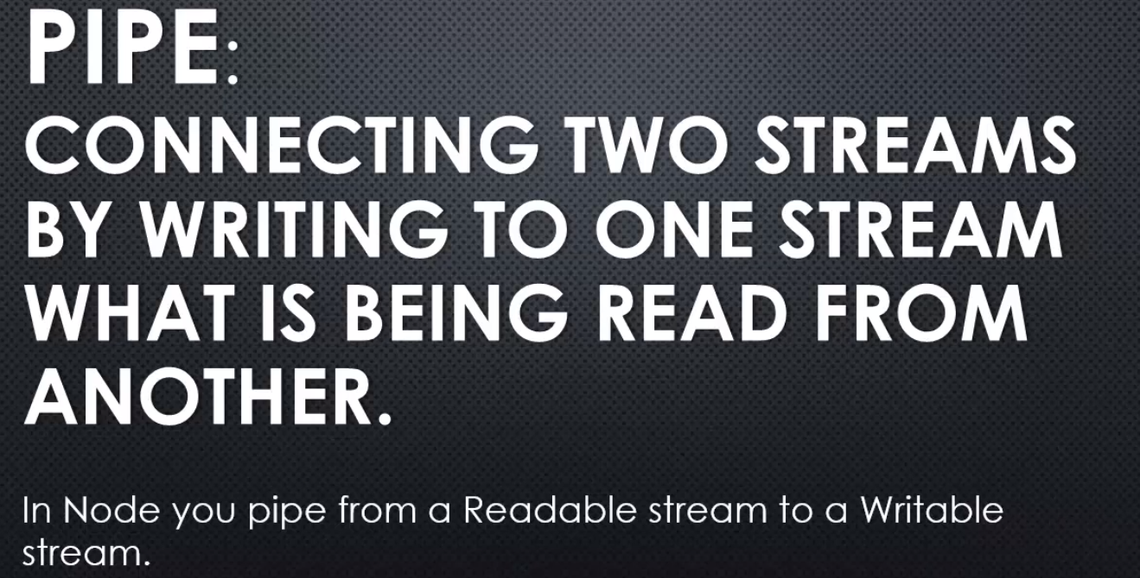

**So, you pipe from a readable, I'm reading what's coming in, each chunk and then I'm writing to the writeable stream that chunk,**

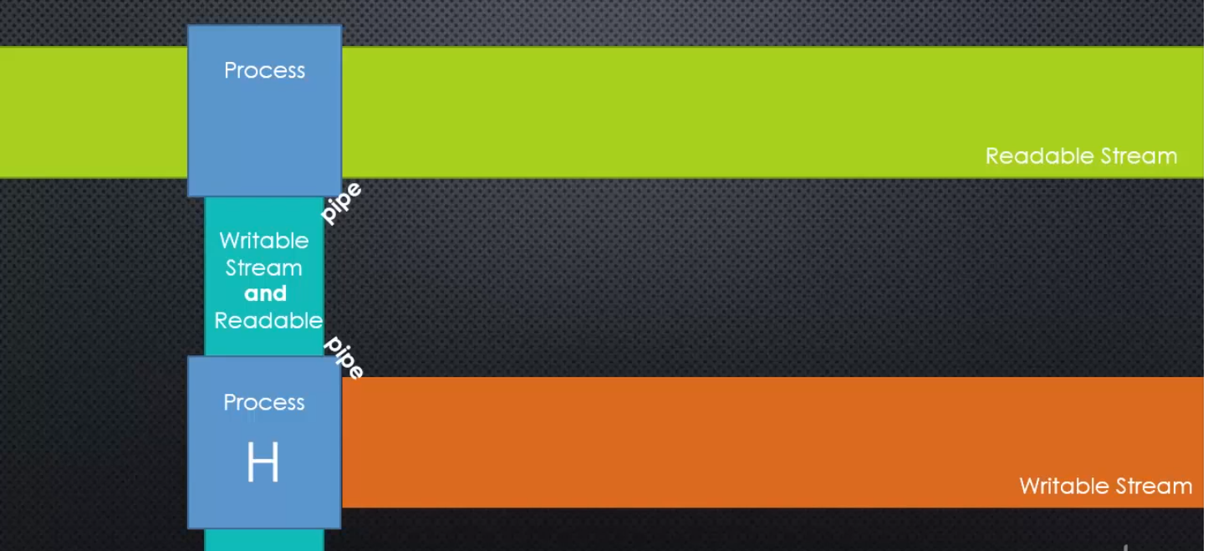

**Node.js implemented a method called pipe, that is available on a readable stream.**

let's go over to the Node.js source code and on the javascript side in the _stream_readable.js file, for example. I'll find a pipe method that's available to all readable streams.

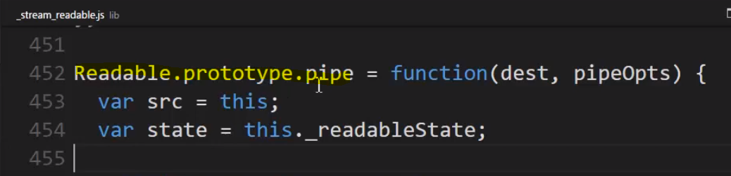

**pipe takes a destination. Where do we want to send this chunk to? This should be a writable stream.**

The value it returns is the destination. So in other words, the value we gave the pipe function, the writable stream that we want to write to, the pipe function also gives that back to us after it's done doing the work it needs to do and that helps us write our code in a bit cleaner fashion.

Let’s implement this 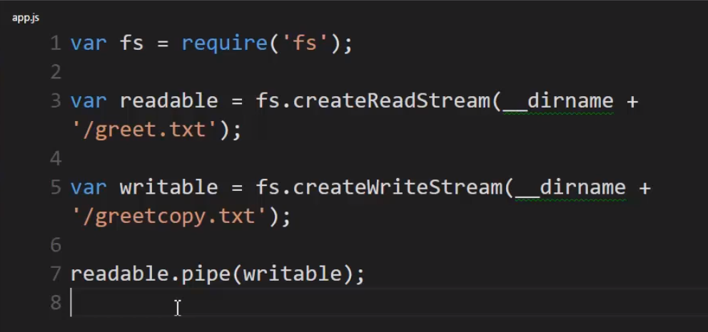

**Remember the pipe function returns the destination, so if I give it this stream, that's what I'll have as the return value of the function. That means that if this was a readable stream, meaning some form of duplex, because I need to pipe to it so it has to be writable and now I'm looking to read from it, meaning it's readable. And if it's both readable and writable, then it's duplex, or transform. If it was, then it would be a readable stream and I could just call pipe on it, not pipe on readable, but pipe on the destination, because that's what's returned from this function.**

**So in that way, I can pipe the chunk through various streams as long as they're both readable and writable.**

**files are a particular type of stream that we're working with, but that doesn't mean that we can only stream from a file to a file.**

**We can really stream a chunk of data to anything that is a stream, like an internet connection or in our case we're going to use something called zlib that is part of the Node core. This simply allows us to implement a gzip file.**

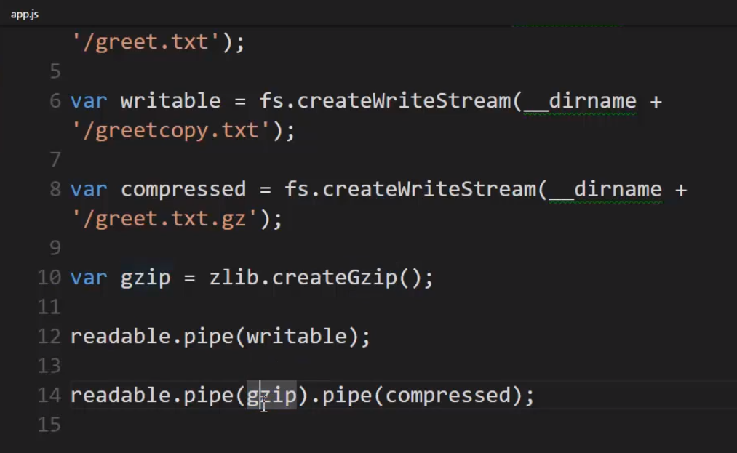

**gzip = zlib.createGzip.**

**It creates a transform stream. That means it's both readable and writable and every time a chunk is sent to it, it compresses that chunk, more or less. In other words, it's creating a compressed file, but it's a stream so it's dealing with the file a chunk at a time, which means since it's readable, not just writable, I can also pipe its output to another writable stream.**

**Now I want to send it through the compressor. Notice that the zlib library is not doing anything with it. It's not saving it to a file. It's simply giving me an output. I give it a chunk of data and it gives me the proper output, the proper compressed output. So pipe will send my readable chunk to my writable stream and gzip will transform that chunk and since the pipe function returns the gzip stream, in this case, return is what I've given to it, I can just say.pipe because gzip is also readable so it also has a pipe method and I can pipe it to my writable compressed stream because I created a writable stream pointing at that file.**

**We could've also streamed this out if we had a stream that was doing an internet connexion or a stream sending data to a database. As long as the stream is implemented properly in that it handles a chunk of a data at a time, you can read and write and pipe data where ever you want from stream to stream, as long as they're properly readable, writable or both.**

**we should always be thinking about, "Where can I use a stream," because it minimises the buffer size**

**Your first instinct should be streams and asynchronous because it will help the performance of your application and you'll be taking full advantage of the power of these concepts within Node.js.**

## **Note :**

**So We've seen a way to deal with work that takes a long time. Just that very asynchronous concept is one of them. We can keep our code running in the V8 engine while other things are happening asynchronously within Node or in the operating system. And the event loop helps us then to know when that happens, and when V8 is done working, it will execute the callback that we ask it to.**

**we've also seen streams. Rather than dealing with large amounts of data at a time, we can deal with data a chunk at a time, so that even though it still takes time for those things to happen, we can deal with it in a way that's both more performant, better performing.**

# **HTTP and being a web Server**

## **TCP/IP**

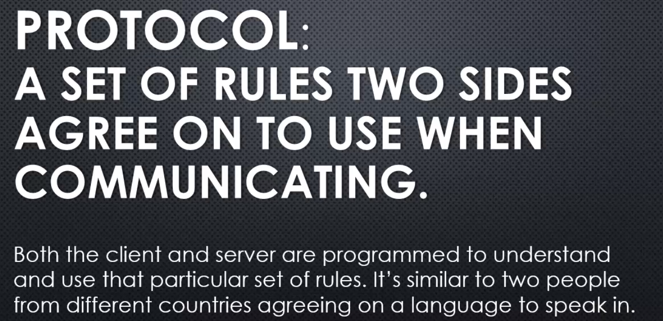

**IP stands for internet protocol. And at its most basic, since a protocol is a set of rules, IP means we've agreed that this sequence of numbers will be the identifier for how we connect two computer systems together, how we identify which is which that we wish to communicate with. So that at its most simplest is IP.**

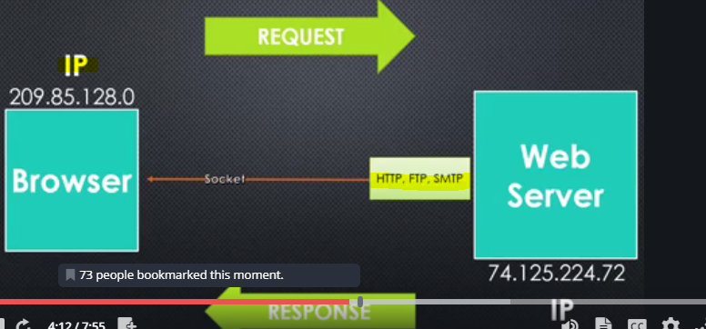

A **socket** is the line across which information flows, if you want to think of it that way. It's where the information actually flows as it's moving from one computer to another. It's the idea of a socket.

**Now that information normally is structured within its own type of protocol, whether it's HTTP, FTP, SMTP, the Ps in all of those stand for protocol, a particular set of rules for how the information is structure, HTTP for web, FTP for files, SMTP for email, and there are others.**

**And then how do we send that information?**

**the way that information is sent is called TCP or transmission control protocol.**

**So again, the information itself may be defined by a protocol, what is in this package. But the act of separating it into packets, into small pieces, and sending it along the wire is TCP. And because we need IP to know where to send them, we typically refer to both of these protocols together, TCP/IP.**

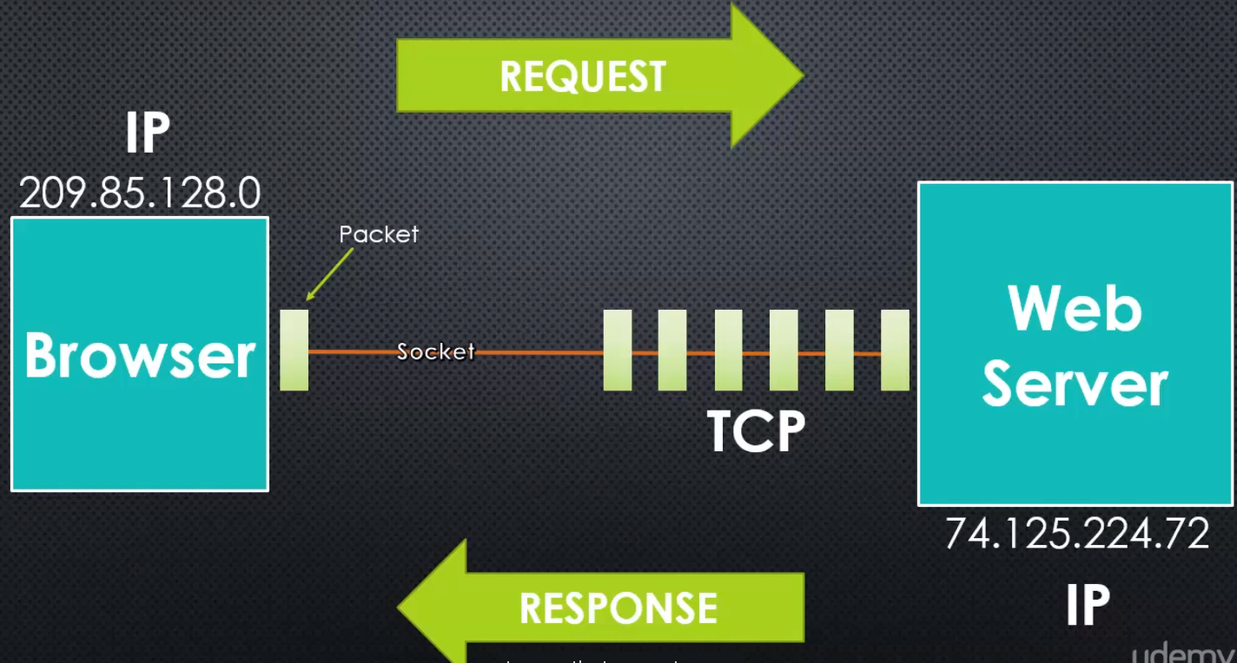

**Your operating system has this capability. And Node then provides the ability to access those features of your operating system, the ability to create a socket and make that network connexion to send information over TCP/IP.**

Now **you might be thinking two things. One, TCP looks an awful lot like a stream, a chunk or a segment or a packet as it's called of data being sent at a time.**

And you're right.

**In the end, it's the same concept. It's the idea of a stream.** so because of that, Node treats these packets coming along down the pipeline as a stream,and we'll see that later.

**So the idea is that,the web server then perhaps will receive information or the browser will receive information split up as packets and Node chooses to see that as a stream.**

## Address and Ports

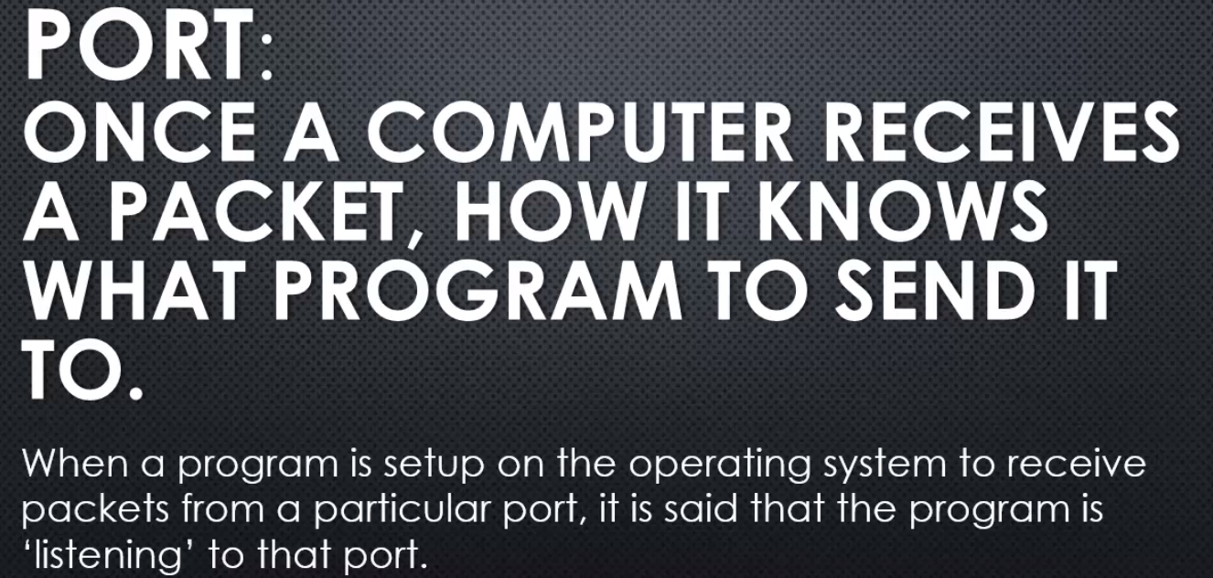

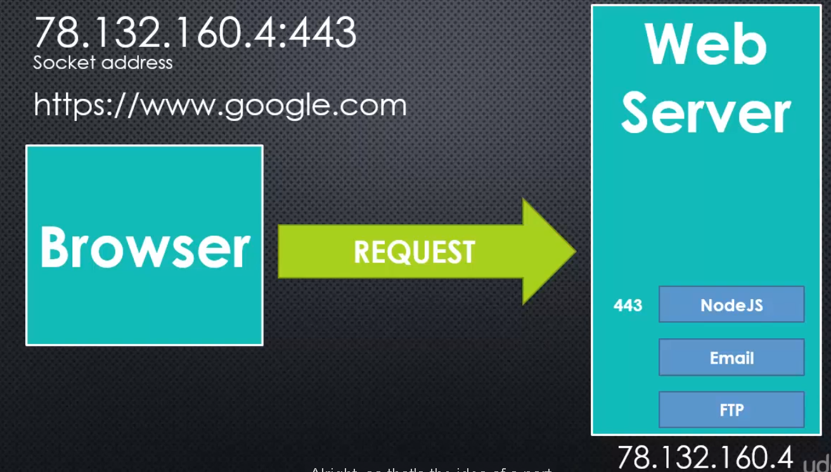

## **HTTP – Hyper Text Transfer Protocol**

Data defined within the set of rules for how to format an HTTP request or an HTTP response is then split into packets as defined by TCP.

HTTP is used not just to send HyperText, that is html, but lots of information like JavaScript files, and images, and other things.

It's the core of how we send information on the worldwide web, web pages, web applications, and images, CSS files, JavaScript files, etc.

**The server and the browser understand what all of these different possible values mean.**

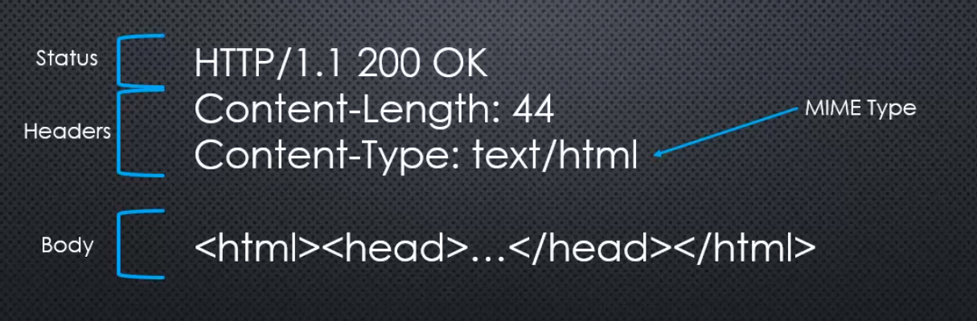

**Here we're showing some html which is very common, but it could also be the data that defines an image, json data, a JavaScript file, a CSS file, whatever we're sending across the internet defined by the HTTP concept, that protocol.**



**Node.js is coded not just to be able to respond and send HTTP responses, but it can also go out and request information from the internet, elsewhere on the internet itself and make an HTTP request.**

**Lets look into http.js**

**I can actually find a method called createServer. And it says "give me a listener." So in other words, a function that will be invoked whenever information is sent to me. So, when an HTTP request shows up, then run this function, and that function will then handle what it should do with that request, and it will also give that function the ability to respond to that request. And that's what a server does, it accepts requests and it gives a response.**

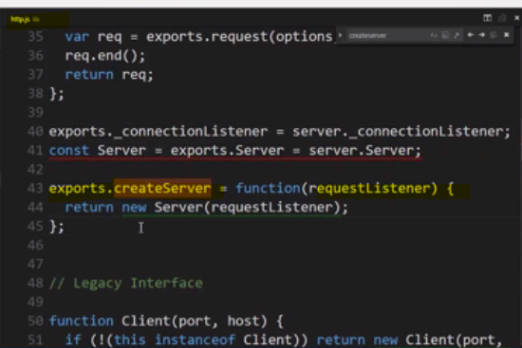

## **Build a webserver in node**

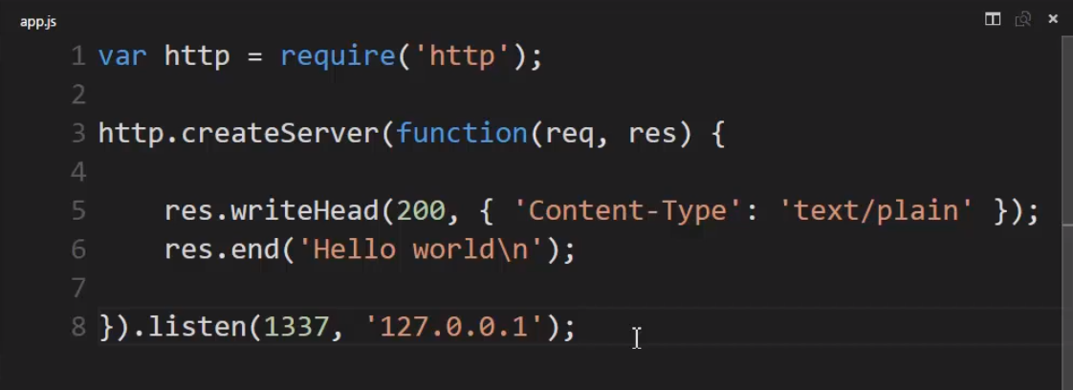

**So we understand the require function and getting from the node js core. We understand, then, that this is creating an object and giving a callback, which actually is turned into an event listener using the event emitter code inside node js, and that I have an HTTP request and a response, which has some methods which allows me to send information back down the stream, things like the status and the headers that our information at the browser will use to interpret what I'm sending and the body of the data itself that I'm sending, and that node js will take all this information and create a properly formatted HTTP response that the browser can then understand and is programmed to do things with, and ultimately, this listen for the port and address will make sure that that request from the browser is routed properly to this code ultimately.**

**Making endpoints/api with NodeJS**

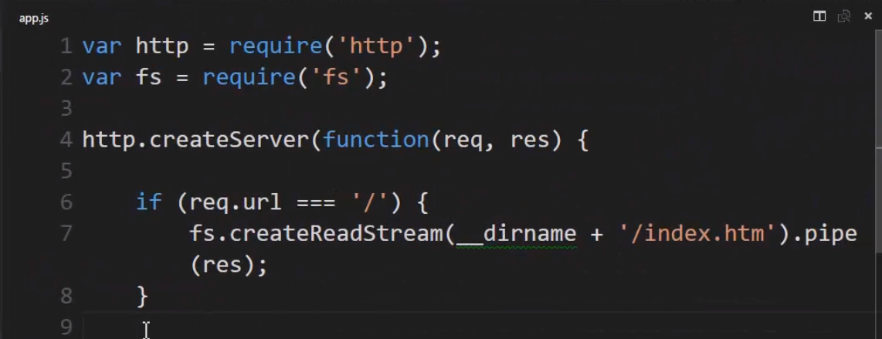

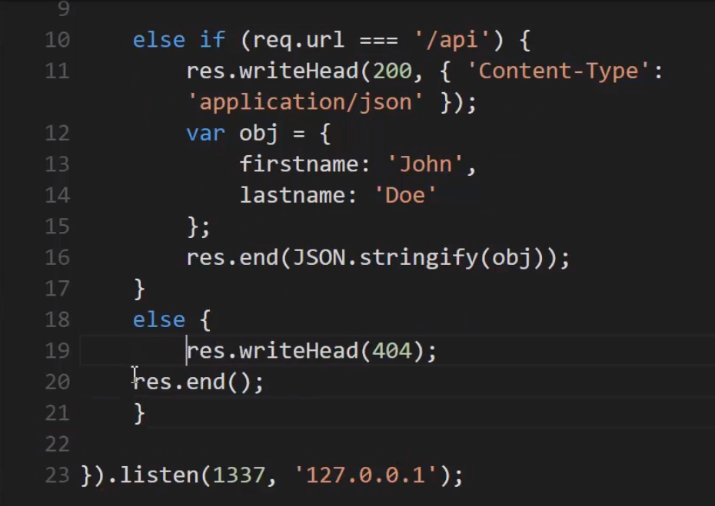

# **NPM : The node package manager**

**The largest ecosystem of open source code in history (NPM Registry) and what gives you access to it. NPM, the Node Package Manager.**

**Package - It's just a collection of code, that works and you can use it in your code. And it's managed and maintained with a package management system. So that makes it a package. You manage and maintain it inside the system and when it's inside that system it's called a package.**

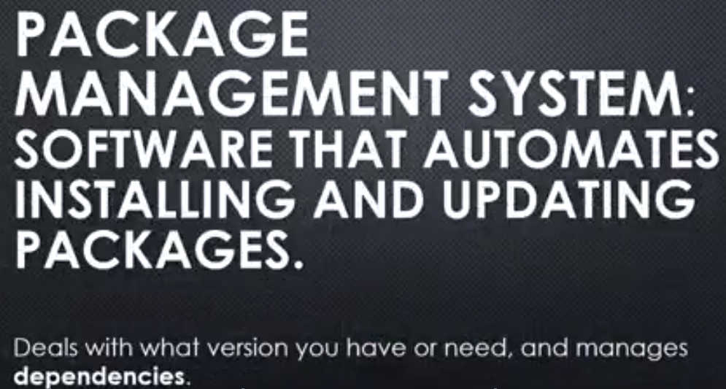

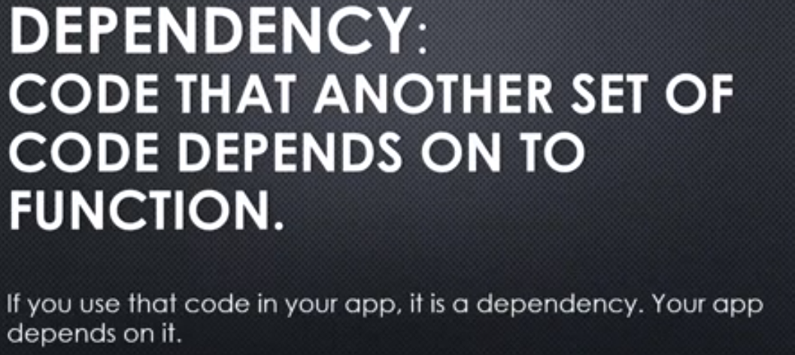

You depend on that other code. And the package might itself have dependencies where it depends on other code to work, etc., etc. So this can get really crazy if you don't have a good package management system to know what code depends on what code

## **Semantic Versioning**

Versioning: specifying what version of a set of code this is so others can track if the new version has come out, watch for new features, or watch for what's called breaking changes, where if they update to the newest version, some of the code they've written against the old version might break, because of things that have changed.

**the version number is based on rules. So if you agree to use semantic versioning, you agree to follow a certain set of rules, when determining the current version number of the code you're writing. I make a change and so I will change the version number this way.**

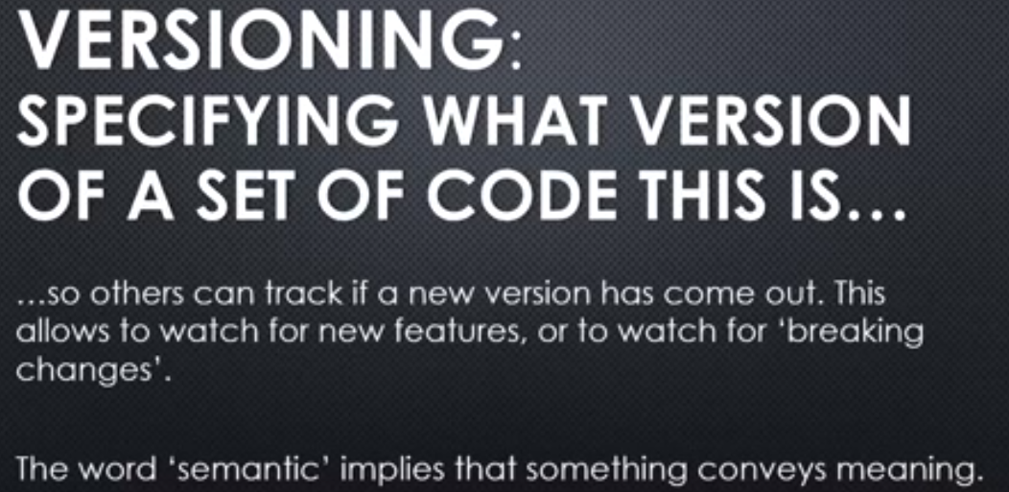



**I would increment the patch number if some bugs were fixed.** So I make some bugs fixes and anyone out there using my code, their code to use my code will still work fine. I didn't make any changes, that would break someone else's code, that was using my module, or my package. So some bug fixes, your code will work fine.

**If I increment the second number, a minor update. That means that I've actually added some new features, not just bug fixes, but your code will still work just fine. It's still backward-compatible. Anything you've written and are using my package, my code, your code will still work just fine.**

**if I make a major change and update the version, the major portion of the version number, that means big changes and your code will maybe break.**

**that means that you need to take a good look at your code, if you do the update, because something major might have changed and I should probably document the kind of breaking changes, that it would cause.**

## **NPM and NPM registry : Other’s people code**

**when we talk about NPM, we're talking about two different things sometimes when developers talk about it.**

**1)NPM the registry, the packages themselves, the collection of packages and NPM the programme, the actual programme that's installed on your computer 2) the package management system itself.**

**So NPM comes along for the ride when installed along with Node.js. So NPM essentially comes with Node.js.**

**when you run NPM to install a package,**

**that is to download some code for use in your application, where does it come from?**

**The code comes from the NPM registry and you can search the registry and look at individual packages and details on them at npmjs.com.**

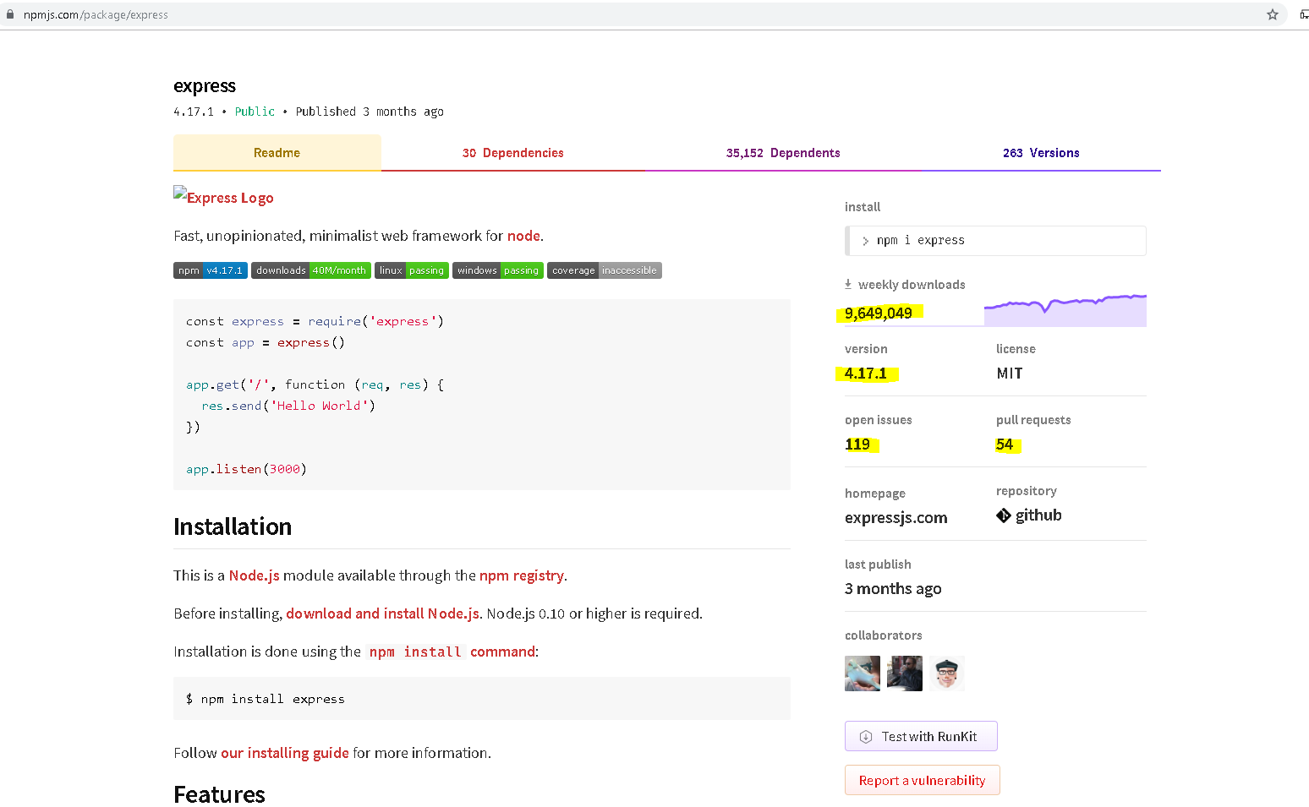

## **npm init , nodemon and package.json**

**we have to set-up, my app, so that it can keep track of the packages that I'm installing, the versions that I'm using, and that I could give it to another developer and they could easily also know which packages this app depends on.**

So to use that we're going to use **NPM init.**

**All right so what did NPM init do. Well you see it created some JSON. All my settings, and it stored it in a file that it just created for me called package.json.**

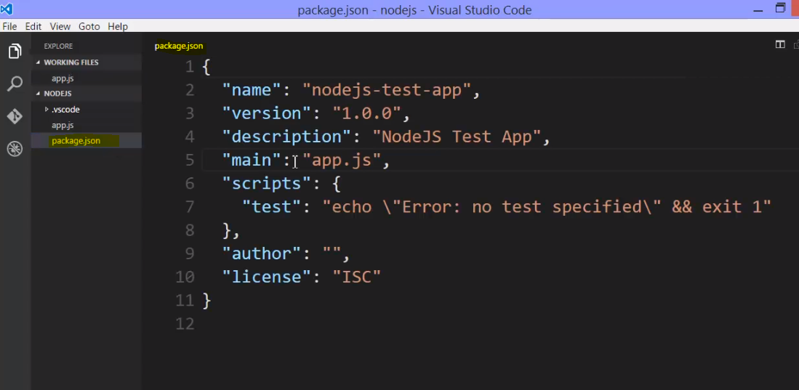

Now I could have done this manually, but you can use NPM init when you initially set up your new app, to help you do it quickly.

**One thing of note is this script section. This is basically command line, commands. Given a name. And I can say NPM and then this name, and run some scripts. So this is a way for me to quickly run some command line, so I could say NPM test as we only have one script specified yet.**

**Now lets install a node package “moment” to see what happens.**

**npm install –save moment**

**NPM, the programme installed on my computer, will go to the NPM registry on internet, download the files that involve moment**

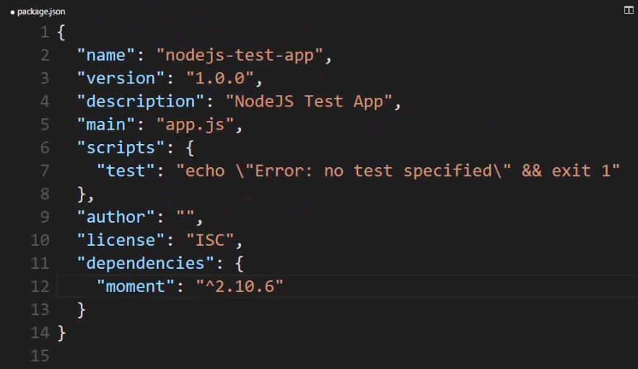

**--save will save a reference in that package.json, to this dependency.**

**One, a new folder is created, automatically, in my app called node_modules. This is standard. This is how we get external modules and pull them into Node.**

It said the name of the NPM package, and then a character, a caret, and then a version.

**The caret is very important.**

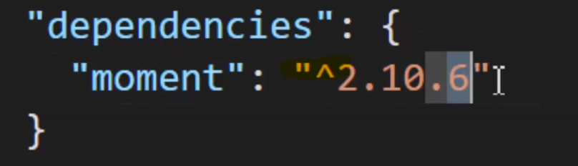

**This means that when we go to update(npm update) to the next version, if a new version of moment comes out, the caret means "NPM, it's okay to automatically update me." To anything within this major release, the two. So if, uh, 2.10.7 comes out, automatically update me. If a 2.11 comes out, automatically update me. But if it changes to a three, don't update me. So in other words, any minor or patch change is okay.**

**If you change this to a tilde,**

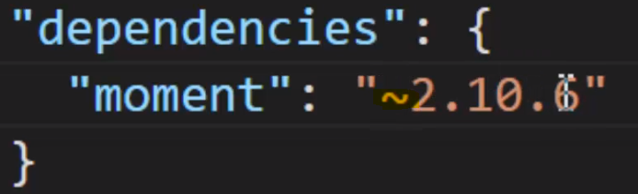

as sometimes you'll see, **that means only give me patches. Don't give me even minor updates. So in that way you can say how careful you want to be about updating to new versions of the packages that you're using.**

**But the really great thing, is that now I have this module available to me. And I have the dependency listed. That means I could go and give this package.json to someone else and they'd know what NPM packages are needed, to run this app.**

**if I just delete this Node module's folder. This is often what you'll get as a developer. Whatever Js files or the app, and the package.json. To save a lot of space in our, let's say our code repos if we're using GitHub or some other form of storing your code, we don't store the folder Node modules. Because we don't need to.**

**We're not editing that content. That's packages being downloaded and used. We only ever need to push package.json, into whatever repository of code we're using, to share with other coders, and all you have to do is here, in the command line, say npm install, by itself.**

**how do we get access to this module?**

**It's a feature built into the require function. Remember how we said that require, has different capabilities as far as where it looks for things. If I do a ./ or ../, I'm saying a local module. Something in my folder structure.**

**If I just give it a name, it will first look for something in the Node core. Is something there in the Node core that matches but if it doesn't it does some other things. It looks other places and one of the places it looks, is for a node_modules folder, in your app. And if there's node_modules folder in your app, then it looks for that package there. It actually looks elsewhere as well(packages install globally in your computer appdata folder in c:/user).**

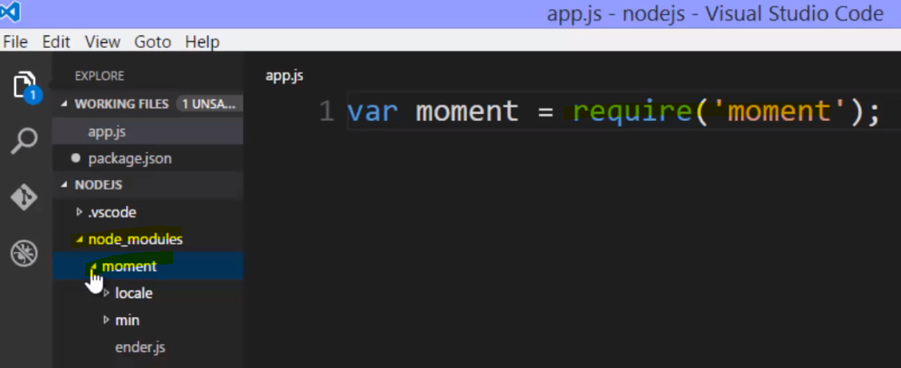

**So we've already seen that we have the special package.json file, and isn't really used by Node itself but rather by NPM. The Node package manager. That programme on your computer. And when you install a package, downloading it from the NPM registry automatically, you can use --save in order to automatically save that reference to the package.json, or you could build this package.json yourself, or receive it from someone else and use NPM instal by itself. Just that phrase to automatically download all the dependencies. Now we called them dependencies because we use them in our app. My app won't run without this package.**

**Development Dependence – DevDependencies**

**For example - I don't need the test for the app to actually run, but I do need it and want to use it while building my app, and other developers who might work on this with me should also have this installed. So I can either add this directly to the package.json or say --save-dev.**

**when you deploy Node, when you actually push it up to a server, you don't push the Node modules at all.**

**There are utilities, server utilities that are already built in that will look at your dependencies, and essentially run the npm install after you push up your code.**

**So ultimately the server where you place your code will do the same thing we just did. Install all the Node modules when you first deploy your code. Push your code up to the server, and make sure that, it will have node_modules folder what is needed.**

**It can ignore the dev dependencies and the server can choose to just install the dependencies.**

There's one other kind of package that we might use. It's a package that again, doesn't have to be there for our app to run. And it is something that we're using for development. But it's something that we're using for development on all of our Node applications or might use on all of our Node applications. Not just this one particular.

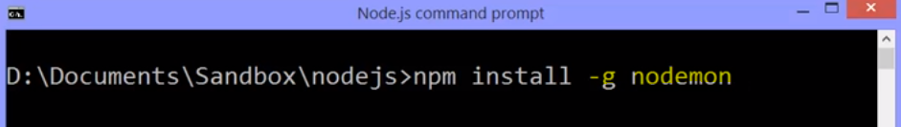

**-g, that means globally install this module. In other words, don't download into that node_modules folder for this particular app, but rather put it in a location that NPM and Node can access it from anywhere on my computer from any app that I'm working on.**

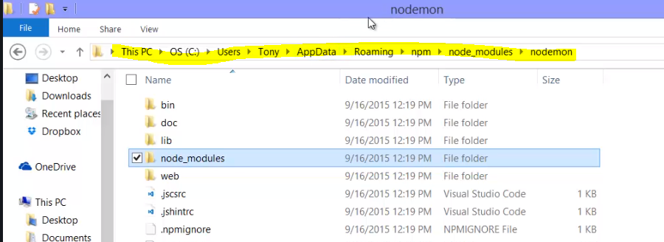

**So there are various places where a package, a module could be installed. You might have a local module, you might have one downloaded from NPM installed locally in a local node_modules folder. You might have something installed in a global node_modules folder. And all those places are places where Node can go and look for things.**

What if the version of one of my dependencies is now old? What if there's a newer version out?

**Well the till day and the kerat take care of what version are allowed to be updated. I don't have to think too hard. I can just go to the command line and say NPM update.**

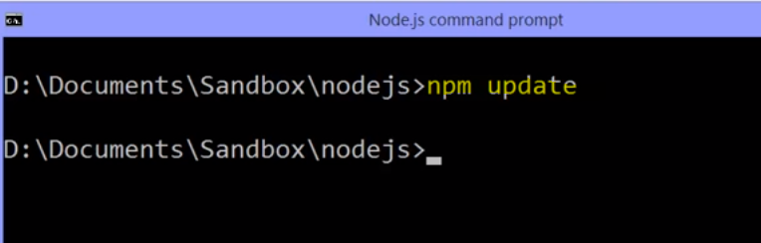

So let's use nodemon. We installed it globally. Which means that because, when I went and looked at the documentation for nodemon, after it's installed globally, I can just use it in the command line.

**The reason being that nodemon comes with what's called a command line interface utility.**

**Often you'll see that NPM packages will have something that lets you use them in the command line. And if they have it and you have it installed, then you should just be able to use it in the command line. Just like I did Node itself.**

**In fact, I can just say nodemon app.js. And it starts the command Node app.js. But inside of it, nodemon or Node monitor watches the files in your app using built in functionality from the FS module within node, and it watches these files and waits for them to change,**

**and if any of the files change, nodemon automatically cancels Node and runs that Node command again. Pointing at the JavaScript file that I gave nodemon.**

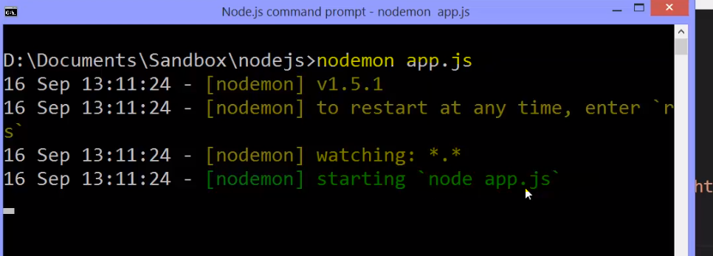

**So all nodemon did was automate whenever I save a file, stopping and restarting Node.**

**So this is the idea of NPM. Useful things, other people's code, available to me out there on the internet. And I can download it from the NPM registry. Register it in the package.json file as dependencies or dev dependencies. They're in the node_modules folder. So I can grab them with the require function.**

**This is how Node caused such a huge explosion of open source code because it made it so easy to grab and use. I have access to this entire library of 10s of thousands of other people's code modules.**

**Pretty neat right?**

**Some of them are new, some of them are incredibly popular and have been around a long time. The idea is I can easily say this is what I'm using, instal it, update it, and just focus on building good software.**

**the package registry is unbelievable. It is one of the greatest things to ever happen in the open source community, and that's a great reason to be a fan of Node.js.**